February 15, 2017

Specialized Press Contact
Janusz Berger
Communication Manager
High Performance Polymers
Phone +49 2365 49-9227
janusz.berger@evonik.com

Evonik Resource Efficiency GmbH
Rellinghauser Straße 1-11
45128 Essen
Germany
Phone +49 201 177-01
Fax +49 201 177-3475
www.evonik.com

Supervisory Board
Dr. Ralph Sven Kaufmann, Chairman

Executive Board
Dr. Claus Rettig, Chairman
Dr. Johannes Ohmer,
Simone Hildmann,
Alexandra Schwarz

Registered Office: Essen
Register Court: Essen Local Court
Commercial Registry B 25783
VAT ID no. DE 815528487

Evonik develops new PEEK powders for tribological coatings

Greater efficiency thanks to lower friction: The innovative polyether ether ketone (PEEK) powders VESTAKEEP® developed by Evonik significantly reduce the wear and tear of components in demanding industrial applications.

PEEK powders for demanding applications
The PEEK powders of Evonik's VESTAKEEP® brand are particularly suitable for applications that are subject to extreme mechanical, thermal and chemical requirements. The coating material is able to withstand permanent operating temperatures of up to 250°C and is characterized by its unique ability to resist abrasion and chemicals.

Thanks to the excellent tribological performance of coatings made from specially developed VESTAKEEP® powders , the friction between sliding surfaces is significantly reduced, which in turn increases efficiency and economy of operation – for example lower fuel consumption and lower CO₂ emissions in combustion engines, extended service life of bearings, or higher turbine speeds. These special VESTAKEEP® coatings also allow for employing more cost-efficient substrate materials for components used in applications with sliding friction.

High performance in powder form
The various VESTAKEEP® PEEK powders are comprised of particles with average particle sizes ranging from 5 to 110 µm. They can be applied by flame and electrostatic spraying methods, or as aqueous dispersions. With electrostatic application, layer thicknesses can range from 20 and 300 µm; dispersions are suitable for thinner layers.

Based on over forty years of experience, Evonik has been a leader in the development and production of high performance polymers. VESTAKEEP® PEEK powders are part of the high-temperature polymers product portfolio offered by the Resource Efficiency Segment.

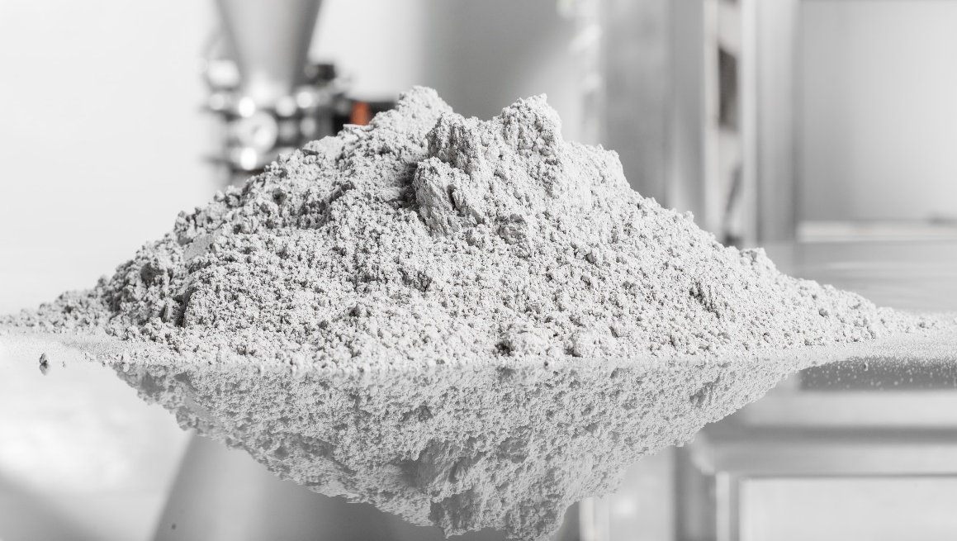
Caption: New VESTAKEEP® PEEK powders for tribological coatings.

To learn more about tribological coatings made from VESTAKEEP® PEEK by Evonik, visit our booth 323 in Hall 7A at the European Coatings Show in Nuremberg from April 4-6.

Follow us on Twitter, LinkedIn, Facebook and Google+

For further information, visit www.vestakeep.com

Company information
Evonik, the creative industrial group from Germany, is one of the world leaders in specialty chemicals, operating in the Nutrition & Care, Resource Efficiency and Performance Materials segments. The company benefits from its innovative prowess and integrated technology platforms. In 2015 more than 33,500 employees generated sales of around €13.5 billion and an operating profit (adjusted EBITDA) of about €2.47 billion.

About Resource Efficiency
The Resource Efficiency segment is led by Evonik Resource Efficiency GmbH and supplies high performance materials for environmentally friendly as well as energy-efficient systems to the automotive, paints & coatings, adhesives, construction, and many other industries. This segment employed about 8,600 employees, and generated sales of around €4.3 billion in 2015.

Disclaimer
In so far as forecasts or expectations are expressed in this press release or where our statements concern the future, these forecasts, expectations or statements may involve known or unknown risks and uncertainties. Actual results or developments may vary, depending on changes in the operating environment. Neither Evonik Industries AG nor its group companies assume an obligation to update the forecasts, expectations or statements contained in this release.

