March 15, 2017

Specialized Press Contact
Janusz Berger
Communication Manager
High Performance Polymers
Phone +49 2365 49-9227
janusz.berger@evonik.com

Evonik Resource Efficiency GmbH
Rellinghauser Straße 1-11
45128 Essen
Germany
Phone +49 201 177-01
Fax +49 201 177-3475
www.evonik.com

Supervisory Board
Dr. Ralph Sven Kaufmann, Chairman

Executive Board
Dr. Claus Rettig, Chairman
Dr. Johannes Ohmer,
Simone Hildmann,
Alexandra Schwarz

Registered Office: Essen
Register Court: Essen Local Court
Commercial Registry B 25783
VAT ID no. DE 815528487

Evonik’s VESTAKEEP® PEEK featured in new Suture Anchor System

Evonik’s VESTAKEEP® PEEK was selected as the material of choice for use in the KATORTM Suture Anchor System, which has been used in its first surgical cases in rotator cuff repair and Achilles tendon reattachment.

Evonik’s VESTAKEEP® PEEK adds structural integrity to KATOR’s new system and the repair construct’s superior strength allows surgeons to repair rotator cuffs or reattach Achilles tendons using fewer suture anchors.

“Evonik is dedicated to contributing to the advancement of new surgical technologies with our medical device partners. With our strength in innovation, we’ll continue to develop the VESTAKEEP® portfolio to bring advanced PEEK polymer technologies to the medical device industry,” said Vikram Chatur, Vice President and General Manager for High Performance Polymers.

“VESTAKEEP® PEEK’s high fatigue resistance has proven critical in the successful development of the KATORTM Suture Anchor System. The KATORTM Suture Anchor System’s anchors receive high stress loads throughout the healing process. In order to handle those loads, we have developed a construct with superior strength using our unique, patented technology along with Evonik’s VESTAKEEP® PEEK”, said Lane Hale, Executive Vice President of Surgical Frontiers.

With the high performance mechanical and biocompatible properties of VESTAKEEP® PEEK and KATOR’s advanced systems for tissue-to-bone reattachment, surgeons can now repair torn rotator cuffs and reattach Achilles tendons using fewer suture anchors, thereby preserving more bone, and improving blood flow available for tendon healing.

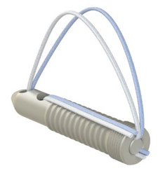
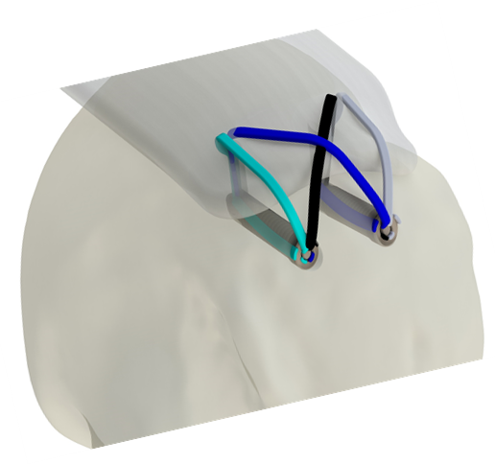

Caption: Evonik’s VESTAKEEP® PEEK featured in new KATORTM Suture Anchor System.

To learn more about Evonik’s VESTAKEEP® PEEK for medical applications, visit our booth C12 in Hall 1 at the Medtec Europe in Stuttgart (Germany) from April 4-6.

Follow us on Twitter, LinkedIn, Facebook and Google+

For further information, visit www.evonik.com/vestakeep-medical

Company information
Evonik, the creative industrial group from Germany, is one of the world leaders in specialty chemicals. Profitable growth and a sustained increase in the value of the company form the heart of Evonik’s corporate strategy. Evonik benefits specifically from its innovative prowess and integrated technology platforms. Evonik is active in over 100 countries around the world with more than 35,000 employees. In fiscal 2016 the enterprise generated sales of around €12,7 billion and an operating profit (adjusted EBITDA) of about €2.165 billion.

About Resource Efficiency
The Resource Efficiency segment is led by Evonik Resource Efficiency GmbH and supplies high performance materials for environmentally friendly as well as energy-efficient systems to the automotive, paints & coatings, adhesives, construction, and many other industries. This segment employed about 9,000 employees, and generated sales of around €4.5 billion in 2016.

About KATOR
KATOR is a start-up medical device company focused on advanced tissue-to-bone reattachment systems and is a portfolio company of Surgical Frontiers.

About Surgical Frontiers
Surgical Frontiers funds, launches and operates start-up companies to develop advanced surgical technologies that are ready for clinical use. Focused primarily on musculoskeletal injuries and pathologies, the company collaborates with surgeons, industry, universities, and investors to bring advanced surgical technologies to the market that improve healthcare.

Disclaimer
In so far as forecasts or expectations are expressed in this press release or where our statements concern the future, these forecasts, expectations or statements may involve known or unknown risks and uncertainties. Actual results or developments may vary, depending on changes in the operating environment. Neither Evonik Industries AG nor its group companies assume an obligation to update the forecasts, expectations or statements contained in this release.

