November 02, 2016

Contact specialized press
Janusz Berger
Communication Manager
High Performance Polymers
Phone +49 2365 49-9227
janusz.berger@evonik.com

Evonik Resource Efficiency GmbH
Rellinghauser Straße 1-11
45128 Essen
Phone +49 201 177-01
Fax +49 201 177-3475
www.evonik.com

Supervisory Board
Dr. Ralph Sven Kaufmann, Chairman

Executive Board
Dr. Claus Rettig, Chairman
Dr. Johannes Ohmer,
Simone Hildmann,
Alexandra Schwarz

Registered Office: Essen
Register Court: Essen Local Court
Commercial Registry B 25783
VAT ID no. DE 815528487
More wear comfort, less weight: Plasteel Eyewear made from Evonik’s VESTAKEEP® PEEK

Together with Evonik, Mentor Optical Limited, an eyewear manufacturer based in Hong Kong, successfully developed its new brand model Plasteel using Evonik’s high performance plastic VESTAKEEP® PEEK.

Plasteel Eyewear
Innovation at Evonik with VESTAKEEP® PEEK supported the creation of the Plasteel Eyewear at Mentor Optical which is a lightweight & tough optical frame with a unique patented plastic rim lock design. The Eyewear weighs just 9 grams whereas traditional frames weigh as much as 23 grams, thereby offering the greatest wear comfortability. In addition, Plasteel frames’ rim height can be designed to be as low as 1.6mm while the thickness at the temple can be as thin as 0.9mm. The frames are ultra-strong and can sustain a 360 bending test without breakage providing performance & protection against broken eyewear especially in sport activities. With a patented plastic rim lock design, the frames allow prescription lenses to be mounted easily and eliminate damages associated with traditional ‘push through’ method.

VESTAKEEP® for Plasteel
Plasteel inherits its excellent mechanical properties and performance from VESTAKEEP® Polyether ether ketone (PEEK) produced by Evonik Industries. VESTAKEEP® PEEK is a high-performance thermoplastic polymer ideal for producing reliable & long-lasting components for use in the toughest conditions. It is characterized by its superior resistance to stress cracking making it suitable for injection molding very thin components. VESTAKEEP® PEEK has a high energy absorption and its ductile behavior can prevent any premature deformation and cracks in the frames. Furthermore, VESTAKEEP® PEEK has excellent biocompatibility and biostability due to the polymers’ high chemical resistance and thermal stability.

Collaboration for success
The success of Plasteel frames is the product of a collaboration between three companies: Evonik, Mentor Optical Limited and Ngai Hing Engineering Plastic (NHEP). Evonik provided the critical material & product know-how while NHEP being the strategic distribution partner supported by offering quick local support to Mentor Optical.

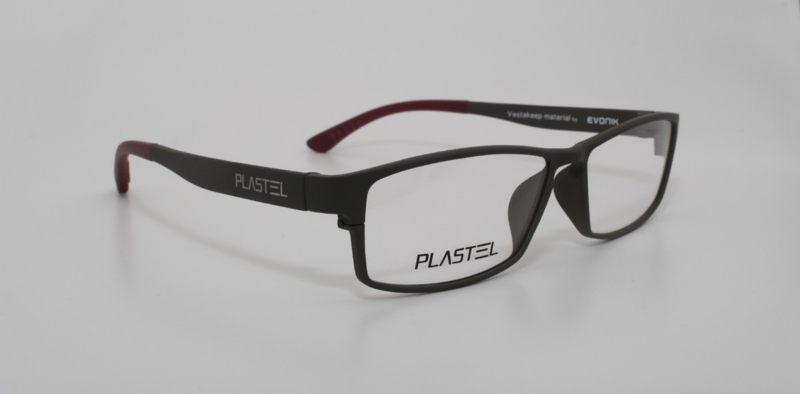

Photo caption: Plasteel Eyewear made from Evonik’s VESTAKEEP® PEEK (Source: Mentor Optical Limited).

Please find further information on www.vestakeep.com
Follow us on Twitter, LinkedIn, Facebook and Google+

Company information
Evonik, the creative industrial group from Germany, is one of the world leaders in specialty chemicals, operating in the Nutrition & Care, Resource Efficiency and Performance Materials segments. The company benefits from its innovative prowess and integrated technology platforms. In 2015 more than 33,500 employees generated sales of around €13.5 billion and an operating profit (adjusted EBITDA) of about €2.47 billion.

About Resource Efficiency
The Resource Efficiency segment is led by Evonik Resource Efficiency GmbH and supplies high performance materials for environmentally friendly as well as energy-efficient systems to the automotive, paints & coatings, adhesives, construction, and many other industries. This segment employed about 8,600 employees, and generated sales of around €4.3 billion in 2015.

Disclaimer
In so far as forecasts or expectations are expressed in this press release or where our statements concern the future, these forecasts, expectations or statements may involve known or unknown risks and uncertainties. Actual results or developments may vary, depending on changes in the operating environment. Neither Evonik Industries AG nor its group companies assume an obligation to update the forecasts, expectations or statements contained in this release.

