February 16, 2017

Specialized Press Contact
Dr. Ursula Keil
Market Communications
High Performance Polymers
Phone +49 2365 49-9878
Fax +49 2365 49-809878
ursula.keil@evonik.com

Evonik Resource Efficiency GmbH
Rellinghauser Straße 1-11
45128 Essen
Germany
Phone +49 201 177-01
Fax +49 201 177-3475
www.evonik.com

Supervisory Board
Dr. Ralph Sven Kaufmann, Chairman

Board of Management
Dr. Claus Rettig, Chairman
Dr. Johannes Ohmer,
Simone Hildmann,
Alexandra Schwarz

Registered Office: Essen
Register Court: Essen Local Court
Commercial Registry B 25783
VAT ID no. DE 815528487
VESTAPE – the new unidirectional tape from Evonik

Marl. Endless, fiber-reinforced plastics offer a promising, innovative solution for lightweight construction. Evonik has developed endless fiber-reinforced UD tapes with thermoplastic matrices to the marketable stage and is now distributing them under the VESTAPE brand.

For some years now, tape manufacturers have been using thermoplastic matrices from Evonik. Now the company itself is manufacturing both glass and carbon fiber tapes using polyamide 12 and specialty high-temperature polyamides. On request, tapes can also be produced using other thermoplastic matrices such as polyamide 6 or PEEK (VESTAKEEP®). The tapes are supplied in rolls 80mm and 150mm wide.

In a unidirectional tape, glass or carbon fibers, which are embedded in a thermoplastic matrix, optimally combine their properties so that innovative construction materials result which enable new component design. Multiple layers of UD tape in a laminate make up organosheets, which significantly exceed the mechanical properties of metal sheets of similar thickness. Organosheets can be thermoformed and can thus assume various component geometries. They also offer the opportunity to integrate additional functions or components, as the parts can be coated with plastic in an injection molding machine. The matrix is made from specially developed high-performance polymers with a high glass transition temperature and therefore features good heat resistance. The polymers are customized to high-strength endless fibers, which allows production of parts that can be used even in areas exposed to extreme temperatures.

Find out more about VESTAPE at the JEC World in Paris from March 14 to 16, 2017, in Hall 5A, Stand J40.

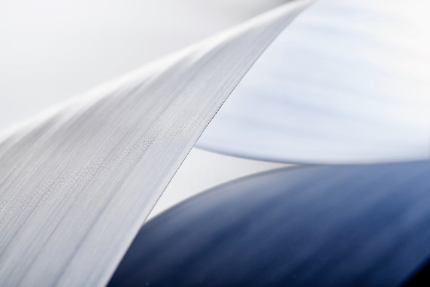

Image caption
VESTAPE UD tapes, a new, innovative product range from Evonik, are opening up new methods of component design in lightweight construction.

Company information
Evonik, the creative industrial group from Germany, is one of the world leaders in specialty chemicals, operating in the Nutrition & Care, Resource Efficiency and Performance Materials segments. The company benefits from its innovative prowess and integrated technology platforms. In 2015 more than 33,500 employees generated sales of around €13.5 billion and an operating profit (adjusted EBITDA) of about €2.47 billion.

About Resource Efficiency
The Resource Efficiency segment is led by Evonik Resource Efficiency GmbH and supplies high performance materials for environmentally friendly as well as energy-efficient systems to the automotive, paints & coatings, adhesives, construction, and many other industries. This segment employed about 8,600 employees, and generated sales of around €4.3 billion in 2015.

Disclaimer
In so far as forecasts or expectations are expressed in this press release or where our statements concern the future, these forecasts, expectations or statements may involve known or unknown risks and uncertainties. Actual results or developments may vary, depending on changes in the operating environment. Neither Evonik Industries AG nor its group companies assume an obligation to update the forecasts, expectations or statements contained in this release.

