VESTAKEEP® enhances safety of automotive steering columns
PEEK polymers by Evonik meet more stringent requirements for electrical steering column adjustment
March 16, 2011

Thomas Lange
Communications
High Performance Polymers
Phone +49 2365 49-9227
Fax +49 2365 49-809227
thomas.lange2@evonik.com

The BMW Group has approved spindle nuts made from VESTAKEEP® PEEK, a polymer made by Evonik Industries, for use in electrical steering column adjustment assemblies. The VESTAKEEP® L4000G-based spindle nuts do not break, even under the most severe conditions. In case of an accident, the spindle nuts will not break and thus preventing any plastic pieces from disabling the function of safety-relevant features such as airbags.

The PEEK polymers that had been used in the past were unable to meet BMW’s stringent requirements and failed during stress tests. Thanks to its improved ductility and impact-resistance, VESTAKEEP® PEEK passed the tests. Evonik’s PEEK polymers also met the requirement of high dimensional stability at different temperatures.

VESTAKEEP® spindle nuts are used in the electrical steering column adjustment assemblies that are manufactured by Solingen, Germany-based C. Rob. Hammerstein GmbH & Co. KG. Thanks to their exceptional material characteristics, they may in the future also be used in mechanical steering column adjustment assemblies.

Du to VESTAKEEP® PEEK polymer’s high resistance to temperatures and chemicals, they are not only used in automotive and aerospace applications, but also in the oil and natural gas sectors, in semiconductor, electronics and medical industry and in numerous other applications.

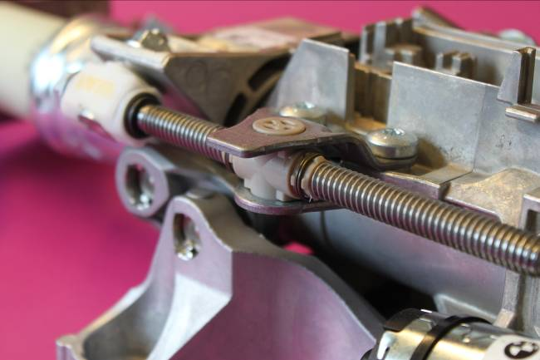
Figure caption:
VESTAKEEP® based spindle nuts passed the stress tests.

Information about Evonik

Evonik Industries is the creative industrial group from Germany. Evonik is a global leader in its core business of specialty chemicals. In addition, Evonik is an expert in power generation from hard coal and renewable energies, and one of the largest private residential real estate companies in Germany. The company’s performance is shaped by creativity, specialization, continuous self-renewal, and reliability.

Evonik is active in over 100 countries around the world. In its fiscal year 2009 about 39,000 employees generated sales of about €13.1 billion and an operating profit (EBITDA) of about €2.0 billion.

Disclaimer
In so far as forecasts or expectations are expressed in this press release or where our statements concern the future, these forecasts, expectations or statements may involve known or unknown risks and uncertainties. Actual results or developments may vary, depending on changes in the operating environment. Neither Evonik Industries AG nor its group companies assume an obligation to update the forecasts, expectations or statements contained in this release.

