Highly Wear-Resistant VESTAKEEP® PEEK Coatings: Evonik and IBEDA Cooperate in Flame-Spray Process
March 31, 2009

Dr. Ursula Keil
Marketing Support
Phone +49 2365 49-9878
Fax +49 2365 49-5992
ursula.keil@evonik.com

The portfolio of Essen, Germany-based Evonik Industries includes a variety of VESTAKEEP® powders that can be used to coat metals. Recently, the company concluded an agreement with IBEDA Sicherheitsgeräte und Gastechnik GmbH & Co. KG that will offer customers a complete solution for coatings applied by the flame-spray process. The mobile IBEDA plastic flame-spraying system F311 FX-S makes it possible to coat large work pieces on site inexpensively and efficiently, without an oven.

VESTAKEEP® coatings applied with this process yield extremely wear-resistant surfaces with outstanding chemical resistance. VESTAKEEP® is hydrolytically stable, with a long-term thermal stability of 260°C (500°F). These properties make it an ideal material for use in such industries as medical technology, aeronautics, automotive, oil, and power. Wolfgang Christoph, an Evonik expert with 25 years of experience in the area of powder coating: "With our know-how and expertise in flame-spraying, we’ve found an ideal partner in IBEDA for offering our customers a complete solution that meets the highest standards."

Flame spraying, developed early in the last century, is one of many types of thermal spraying processes. In this process, the combustion of a gas/oxygen mixture generates the thermal energy to melt the powder and warm the surface of the substrate. A carrier gas—normally compressed air—serves as the medium for transporting the melted particles to the substrate surface. The advantages of this process include low investment costs and the option of coating large parts on site, without an oven. VESTAKEEP® 2000 FP is best suited for this application because it has a sufficiently low melt viscosity.

Evonik has been successfully producing and marketing high-performance polymers for over 40 years and is highly regarded in the market for its technical service experience. On this platform, the company has transferred its know-how in powder technology, among other things, to VESTAKEEP® powder, which it recently added to its portfolio in 2008, and offered it to its newly acquired development partners. The cooperation is for the long run and involves extended accreditation periods.

IBEDA Sicherheitsgeräte und Gastechnik GmbH & Co. KG is one of the world's leading producers of safety equipment and meets all of the most important international and European standards, as well as those at the national level. IBEDA develops and manufactures high-quality fixtures for gas safety engineering, products for central gas supply and autogenous engineering, as well as equipment and complete units for thermal spraying.

Figure caption:
The mobile IBEDA plastic flame-spraying system F311 FX-S makes it possible to apply highly wear-resistant VESTAKEEP® coatings on site (photo: IBEDA).

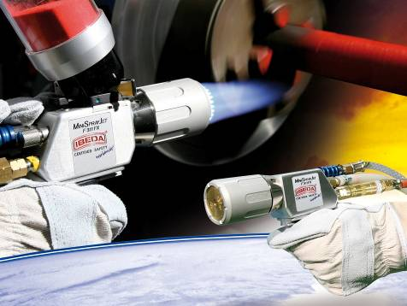

Company information
Evonik Industries is the creative industrial group from Germany which operates in three business areas: Chemicals, Energy and Real Estate. Evonik is a global leader in specialty chemicals, an expert in power generation from hard coal and renewable energies, and one of the largest private residential real estate companies in Germany. Our strengths are creativity, specialization, continuous self-renewal, and reliability. Evonik is active in over 100 countries around the world. In its fiscal year 2008 about 41,000 employees generated sales of about €15.9 billion and an operating profit (EBITDA) of about €2.2 billion.

Disclaimer
In so far as forecasts or expectations are expressed in this press release or where our statements concern the future, these forecasts, expectations or statements may involve known or unknown risks and uncertainties. Actual results or developments may vary, depending on changes in the operating environment. Neither Evonik Industries AG nor its group companies assume an obligation to update the forecasts, expectations or statements contained in this release.

