Chinaplas 2008, Shanghai, Hall W3, Booth No. E21
April 17, 2008

Dr. Ursula Keil
Marketing Support
Phone +49 2365 49-9878
Fax +49 2365 49-5992
ursula.keil@evonik.com

Dr. Joy Xia
Marketing Operations
High Performance Polymers
Phone +86 21 6119 1365
Fax +86 21 6119 1377

VESTAKEEP® used for Just In Make® technique by KDA Corporation

KDA Corporation, Tokyo, Japan, recently introduced the polyetheretherketone (PEEK) VESTAKEEP® as a plastic molding material for use in the Just In Make® manufacturing technique. VESTAKEEP® is produced and globally marketed by the Germany-based Evonik Industries, Essen, a global leader in specialty chemicals.

In the Just In Make® technique developed by KDA, plastic pellets are molded into a block close to the final shape and then machine-cut to form the completed product. This manufacturing process is drawing considerable attention, since it allows for small-volume production runs of various molded products as reasonable cost. According to KDA, VESTAKEEP® was chosen as a manufacturing material because it provides great cost benefits and excellent flexibility in material selection to help increase market competitiveness, not to mention the outstanding properties abs functions inherent in this plastic resin.

The aromatic polyetheretherketone (PEEK) resins are best suited for manufacturing components for long-term use in harsh environments. These parts are found, e.g., in the semiconductor processing, oil exploration, industrial, transport, and medical markets.

VESTAKEEP® PEEK outperforms metals by improving system durability and reducing component manufacturing cost. These benefits are derived from a superior combination of corrosion resistance, abrasion resistance, strength-to-weight attributes, and processing versatility. Use of PEEK eliminates corrosion due to salts, solvents, caustics, and many acids and also reduces abrasive wear due to slurries, particulate impact, and moving surfaces. These properties have allowed PEEK to outperform aluminum, titanium, and steel in air impellers in aircraft, in bushings in mining, pulp, and paper industries. Pound-for-pound, PEEK has a higher strength-to-weight ratio than steel. Lower mass parts provide fuel savings in transport, improved durability in compressor components, and more efficient motor design for gears and impellers. Replacing metals with VESTAKEEP® PEEK reduces component cost due to improved durability, efficient processing methods, part consolidation, and increased design freedom over machined metals.

Compared to other plastics, PEEK provides the best combination of inertness and heat resistance. PEEK retains original properties after long-term exposure to steam, ethylenoxide, and gamma radiation. Low extractables, outgassing, and contaminates make PEEK an excellent material for wafer handling in semiconductor manufacturing processes. PEEK has excellent oxidative stability in the melt and can be used continuously at temperatures exceeding 220°C (dynamic stressed 180°C).

Evonik provides VESTAKEEP® PEEK resins in fine powders for composites, compression molding, and coatings as well as pellets for compounding, injection molding and extrusion. In addition to unfilled products reinforced grades are available to improve cyclic fatigue performance, modulus, and abrasion resistance. Tribological grades are available to reduce friction and wear.

Figure caption: Parts manufactured by the Just In Make® technique of KDA, Japan.

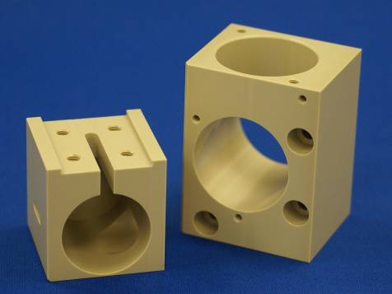

Company information
Evonik Industries is the creative industrial group from Germany which operates in three business areas: Chemicals, Energy and Real Estate. Evonik is a global leader in specialty chemicals, an expert in power generation from hard coal and renewable energies, and one of the largest private residential real estate companies in Germany. Our strengths are creativity, specialization, continuous self-renewal, and reliability. Evonik is active in over 100 countries around the world. In its fiscal year 2007 about 43,000 employees generated sales of about €14.4 billion and an operating profit (EBIT) of more than €1.3 billion (preliminary figures).

Disclaimer
In so far as forecasts or expectations are expressed in this press release or where our statements concern the future, these forecasts, expectations or statements may involve known or unknown risks and uncertainties. Actual results or developments may vary, depending on changes in the operating environment. Neither Evonik Industries AG nor its group companies assume an obligation to update the forecasts, expectations or statements contained in this release.

