April 05, 2016

Specialized Press Contact
Janusz Berger
High Performance Polymers
Phone 49 2365 49-9227
Fax +49 2365 49-809878
janusz.berger@evonik.com

Evonik Resource Efficiency GmbH
Rellinghauser Strasse 1-11
45128 Essen
Germany
Phone +49 201 177-01
Fax +49 201 177-3475
www.evonik.com

Supervisory Board
Dr. Ralph Sven Kaufmann, Chairman
Management Board
Dr. Claus Rettig, Chairman
Dr. Johannes Ohmer,
Simone Hildmann,
Alexandra Schwarz

Registered Office: Essen
Register Court: Essen Local Court
Commercial Registry B 25783
VAT ID no. DE 815528487
MedTec 2016: Evonik is raising the bar in the dental sector with VESTAKEEP® PEEK

At this year’s MedTec Europe in Stuttgart, Evonik will unveil VESTAKEEP® Dental, the high-performance polymer polyether ether ketone (PEEK) for dental applications—a unique biomaterial for medical devices suited to permanent contact with the mucous membrane.

Medical devices based on VESTAKEEP® Dental provide an innovative, metal-free solution in the dental sector, be it for crowns, bridges or removable abutments. The high-performance polymer developed by Evonik is characterized by factors such as outstanding wear comfort as well as excellent biocompatibility and biostability.

VESTAKEEP® Dental—performance and esthetics in one
VESTAKEEP® Dental allows sophisticated dental applications to be realized while taking high esthetic demands into account. Customized or fully anatomical crowns or bridges can be manufactured with composite materials, for example, through full or partial veneering. Here, the high-performance polymer acts as a kind of shock absorber. This property is particularly gentle and beneficial for the antagonist as well as for the jaw joint.

Large and small bridges or partial dentures made of VESTAKEEP® Dental also have the advantage of being light and tasteless. What is more, patients find them exceptionally comfortable to wear and no longer have an unpleasant sensation of hot or cold while eating or drinking.

VESTAKEEP® Dental grades are offered in four different colors—natural, white, tooth-colored, and gingiva-colored (pink)—to meet the esthetic needs of the patient. Partial dentures, for instance, are produced in gingiva-colored PEEK to improve the appearance and to give the patient an extra level of comfort.

Certified biocompatibility and biostability
Like the other VESTAKEEP® medical products, VESTAKEEP® Dental by Evonik for dental applications must comply with strict quality standards. Accordingly to ISO 10993-1 recommendation for permanent mucosal contact, biocompatibility was following tested and confirmed by external testing laboratories.

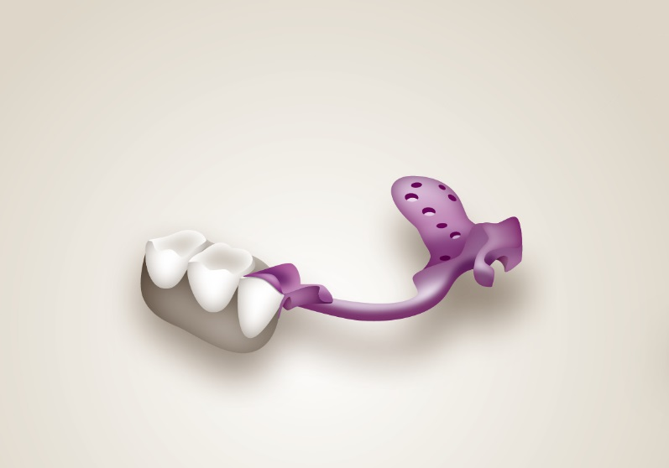

Caption: Graphical example of partial dentures made of VESTAKEEP® Dental by Evonik.

Discover more about VESTAKEEP® Dental from Evonik at our stand 3D04 in Hall 3 at MedTec Europe in Stuttgart, Germany, from April 12 to 14.

About Resource Efficiency
The Resource Efficiency segment is led by Evonik Resource Efficiency GmbH and supplies high performance materials for environmentally friendly as well as energy-efficient systems to the automotive, paints & coatings, adhesives, construction, and many other industries. This segment employed about 8,600 employees, and generated sales of around €4.3 billion in 2015.

About Evonik
Evonik, the creative industrial group from Germany, is one of the world leaders
in specialty chemicals. Profitable growth and a sustained increase in the value of the company form the heart of Evonik’s corporate strategy. Its activities focus on the key megatrends health, nutrition, resource efficiency and globalization. Evonik benefits specifically from its innovative prowess and integrated technology platforms.

Evonik is active in over 100 countries around the world. In fiscal 2015 more than 33,500 employees generated sales of around €13.5 billion and an operating profit (adjusted EBITDA) of about €2.47 billion.

Disclaimer
In so far as forecasts or expectations are expressed in this press release or where our statements concern the future, these forecasts, expectations or statements may involve known or unknown risks and uncertainties. Actual results or developments may vary, depending on changes in the operating environment. Neither Evonik Industries AG nor its group companies assume an obligation to update the forecasts, expectations or statements contained in this release.

