VESTAKEEP® PEEK based Cage System Receives CE Mark Certificate
March 11, 2014

Thomas Lange
Contact trade press
High Performance Polymers
Phone +49 2365-49-9227
Fax +49 2365-49-809227
thomas.lange2@evonik.com

Evonik Industries AG
Rellinghauser Strasse 1-11
45128 Essen
Germany
Phone +49 201 177-01
Fax +49 201 177-3475
www.evonik.com
www.vestakeep.com

Chairman of the Supervisory Board
Dr. Werner Müller
Executive Board
Dr. Klaus Engel, Chairman
Thomas Wessel
Patrik Wohlhauser
Dr. Uwe Wolf

Registered Office: Essen
Register Court: Essen Local Court
Commercial Registry B 19474
VAT ID no. DE 811160003

The LorX® Cervical Peek Cage with Blade System of Tria Spine, Turkey, as well as the LorX® Expandable PLIF PEEK Cage has received the CE Mark Certificate. This next generation cage design is based on Evonik Industries’ VESTAKEEP® polyether ether ketone (PEEK). Evonik supported Tria Spine in obtaining the CE Mark certificate with comprehensive biocompatibility studies and technical documentation of VESTAKEEP® PEEK.

The PLIF Peek Cage has a specially designed body structure for better stability between vertebrae. The teeth structure helps secure placement and prevents migration. A specially designed (patent pending) expanding shaft has graft holes that allow the filling of bone graft after inserting the LorX® Expandable PLIF PEEK Cage.

The LorX® Cervical Peek Cage with Blade has a unique design and is available in various heights to restore the interbody space. The anatomic design and the blade help for a secure and better placement.

“In cooperation with Evonik, we made it possible to replace titanium with the radiolucent and biocompatible PEEK”, says Ibrahim Ozgur Bektas, International Sales Director of Tria Spine. “We have chosen VESTAKEEP® PEEK, because it is known for its excellent mechanical properties but also its superior biocompatibility and biostability. With this material we can achieve the expected features of our innovative cage design.”

Marc Knebel, Director of VESTAKEEP® Medical, adds: “Our PEEK has already received CE certificate, and FDA 510 (K) approvals in a broad range of applications, e.g. spinal implants, suture anchors, or cranial implants.”

The excellent sterilization resistance and good combination of stiffness and ductility of VESTAKEEP® PEEK make it suitable for medical implant applications that must meet the extremely high demands/requirements of the medical industry. VESTAKEEP® PEEK provides a modulus of elasticity similar to that of bone.

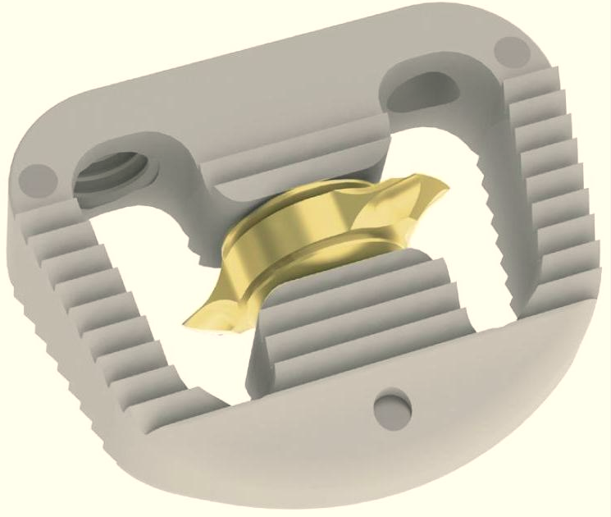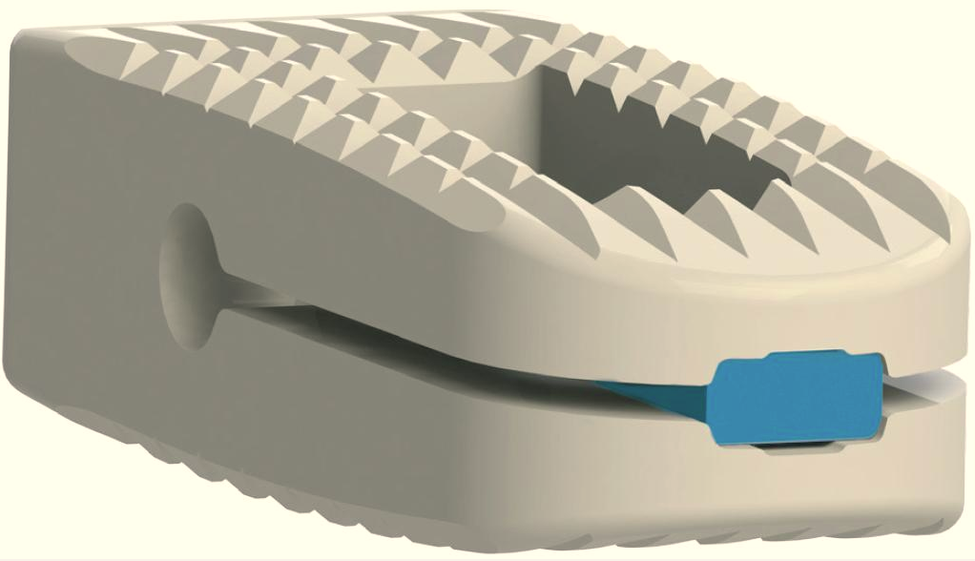
Image caption:
LorX® Cervical PEEK Cage with Blade (left)
LorX® Expandable PLIF PEEK Cage

About Evonik
Evonik, the creative industrial group from Germany, is one of the world leaders
in specialty chemicals. Profitable growth and a sustained increase in the value of the company form the heart of Evonik’s corporate strategy. Its activities focus on the key megatrends health, nutrition, resource efficiency and globalization. Evonik benefits specifically from its innovative prowess and integrated technology platforms.

Evonik is active in over 100 countries around the world. In fiscal 2013 more than 33,500 employees generated sales of around €12.9 billion and an operating profit (adjusted EBITDA) of about €2.0 billion.

About Tria Spine
Tria Spine is a privately owned Turkish company supplying spinal implants and instruments. Almost one decade of experience was combined to design, manufacture and supply spinal fixation systems, and thus the company was founded in 2009. The main aim of Tria Spine is to provide high quality implant and instruments to its customers by following the latest developments in industry.

Disclaimer
In so far as forecasts or expectations are expressed in this press release or where our statements concern the future, these forecasts, expectations or statements may involve known or unknown risks and uncertainties. Actual results or developments may vary, depending on changes in the operating environment. Neither Evonik Industries AG nor its group companies assume an obligation to update the forecasts, expectations or statements contained in this release.

