An Innovative Lightweight and Stable Dental Applicator made from VESTAKEEP® PEEK
January 30, 2012

Thomas Lange
Manager Communications
High Performance Polymers
Phone +49 2365-49-9227
Fax +49 2365-49-80227
thomas.lange2@evonik.com

The DinoPress applicator relies on VESTAKEEP® PEEK. Thanks to this high-performance polymer, the DinoPress applicator, a medical device for applying dental fillings, is now available in an improved version. The working parts, which are subjected to heavy mechanical stress, are no longer made of metal, but from polyetheretherketone (PEEK) from Evonik Industries. Substitution of metal through VESTAKEEP® PEEK reduces the weight of the device noticeably, thereby eliminating user fatigue. Furthermore, the plastic feels warmer to the touch than does the metal, thus making it more pleasant to handle when filling is applied. And DinoPress can be steam sterilized up to 134°C.

The new DinoPress has been developed and optimized jointly by Gossau, Switzerland-based Alfred Schmid AG, specialists and producers of plastic parts for the dental industry for more than 40 years, and Basel, Switzerland-based Dolder AG. “Thanks to its favorable properties, VESTAKEEP® PEEK can be used in many medical technology fields. It's as a metal substitute in particular that PEEK realizes its full potential,” says Beat Imhof, senior sales manager at Dolder AG.

VESTAKEEP® PEEK lends itself better to sterilization and is more durable than titanium alloys. Its outstanding mechanical, chemical, and electrical properties make this plastic an all-purpose material.

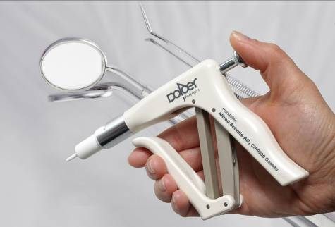

Figure caption:

The DinoPress applicator eliminates user fatigue.

Company information
Evonik, the creative industrial group from Germany, is one of the world leaders
in specialty chemicals. Its activities focus on the key megatrends health, nutrition, resource efficiency and globalization. In 2010 about 80 percent of the Group’s chemicals sales came from activities where it ranks among the market leaders. Evonik benefits specifically from its innovative prowess and integrated technology platforms.
Evonik is active in over 100 countries around the world. In fiscal 2010 more than 34,000 employees generated sales of around €13.3 billion and an operating profit (EBITDA) of about €2.4 billion.

Disclaimer
In so far as forecasts or expectations are expressed in this press release or where our statements concern the future, these forecasts, expectations or statements may involve known or unknown risks and uncertainties. Actual results or developments may vary, depending on changes in the operating environment. Neither Evonik Industries AG nor its group companies assume an obligation to update the forecasts, expectations or statements contained in this release.

