Molded parts made from VESTAKEEP® PEEK and VESTAMID® HTplus shine through induction technology
June 7, 2011

Thomas Lange
Communications
High Performance Polymers
Phone +49 2365 49-9227
Fax +49 2365 49-809227
thomas.lange2@evonik.com

High surface quality and resistance to mechanical stress are requirements that polymer moldings must fulfill—despite increasing functional integration in components and the resulting increase in complexity of component geometry. An innovative induction heating technology from RocTool improves component quality by ensuring a high mold temperature during the injection phase and high cooling rates during the holding-pressure and cooling phases in the injection molding process. In combination with VESTAKEEP® PEEK and VESTAMID® HTplus high-performance polymers, this improves particularly the gloss level of molded parts.

This highly dynamic temperature control selectively influences the formation of the morphology and surface structure. While the gloss levels achieved for the high-performance thermoplastics investigated lie in the range for high-gloss surfaces, the mechanical properties in the tensile test remain almost unchanged as the mold temperature is varied.

Moreover, the wear rate of VESTAKEEP® molded parts, as measured on a pin-disk test rig, is reduced when mold temperatures are sufficiently high. This could, for example, increase the operating life of gears.

VESTAKEEP® PEEK polymers are distinguished by high mechanical strength as well as good electrical insulation and chemical resistance. The polyphthalamide (PPA) VESTAMID® HTplus is known for its high heat resistance and excellent mechanical properties. VESTAMID® HTplus is used as a metal substitute and for fire protection, among other applications.

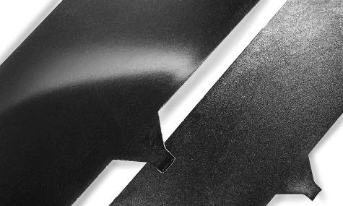
Figure caption
Matt or glossy: VESTAKEEP® PEEK molded parts have a wide range of gloss levels. The part on the left was produced at a mold temperature of 250°C, and that on the right at 180°C.

About Evonik
Evonik is the creative industrial group from Germany. In our core business of specialty chemicals, we are a global leader. In addition, it has energy and residential real estate operations. Our performance is shaped by creativity, specialization, reliability and continuous self-renewal.
Evonik is active in over 100 countries around the world. In fiscal 2010 more than 34,000 employees generated sales of around €13.3 billion and an operating profit (EBIDA) of about €2.4 billion.

Disclaimer
In so far as forecasts or expectations are expressed in this press release or where our statements concern the future, these forecasts, expectations or statements may involve known or unknown risks and uncertainties. Actual results or developments may vary, depending on changes in the operating environment. Neither Evonik Industries AG nor its group companies assume an obligation to update the forecasts, expectations or statements contained in this release.

