Dental implants made from VESTAKEEP® PEEK are suitable for patients with allergies
May 13, 2011

Thomas Lange
Communications
High Performance Polymers
Phone +49 2365 49-9227
Fax +49 2365 49-809227
thomas.lange2@evonik.com

NT-Trading manufactures milling blanks for crowns and bridges made from high-performance polymers by Evonik

VESTAKEEP® PEEK by Evonik Industries is the source material for NT-Trading GmbH’s new semifinished products for the manufacture of dental implants. Dentokeep semifinished products have a number of advantages over materials used in the past. Dentokeep semifinished products have mechanical properties that are superior to those of conventional semifinished products, are easier to process than ceramics, and–compared to titanium–also are suitable for patients with allergies. Furthermore, the high-performance polymer polyether ether ketone (PEEK) is more elastic than metal. This results in enhanced, more natural implant comfort for patients.

Dentokeep is suitable for crowns, bridges, and splints and can also be used for removable structures with support components. “Our decision to use VESTAKEEP® PEEK was based not only on the good mechanical property profile and the biocompatibility of VESTAKEEP® PEEK,” says Dirk Jahn, managing partner of NT-Trading, “but also on the fact that PEEK has been used in the production of medical devices for years." The company further refined the unique material properties of the new bio-material with select additives and a special production process. Prosthetic components designed with CAD/CAM technology can be attached to residual dental stumps or to implant abutments and ensure essential aesthetic and functional characteristics.

Thanks to their special property profile, VESTAKEEP® PEEK polymers are the implant material of choice for other medical applications, including in orthopedic, cardiovascular, and spinal implants, where PEEK is superior to conventional materials such as titanium or cobalt chromium on almost every count.

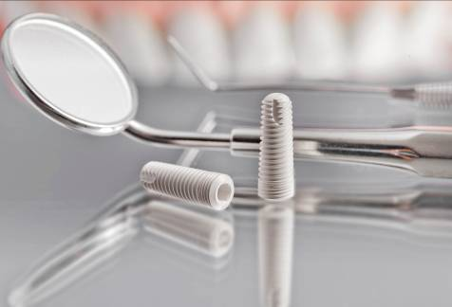
Image Caption:
More natural implant comfort thanks to VESTAKEEP®

About Evonik
Evonik is the creative industrial group from Germany. In our core business of specialty chemicals, we are a global leader. In addition, it has energy and residential real estate operations. Our performance is shaped by creativity, specialization, reliability and continuous self-renewal.
Evonik is active in over 100 countries around the world. In fiscal 2010 more than 34,000 employees generated sales of around €13.3 billion and an operating profit (EBIDA) of about €2.4 billion.

Information about NT-Trading
NT-Trading is an established specialist in dental CAD/CAM technology.
The company’s development and production activities focus on medical devices with key positions in digital dental technology.
NT-Trading is a reliable partner, well known for its innovation and focus on customers and its premium quality “made in Germany”.
NT-Trading is a medical device manufacturer with business activities in Europe, North America and Asia.

Disclaimer
In so far as forecasts or expectations are expressed in this press release or where our statements concern the future, these forecasts, expectations or statements may involve known or unknown risks and uncertainties. Actual results or developments may vary, depending on changes in the operating environment. Neither Evonik Industries AG nor its group companies assume an obligation to update the forecasts, expectations or statements contained in this release.

