Evonik to expand its PEEK polymer capacity
February 22, 2011

Thomas Lange
Marketing Support
High Performance Polymers
Phone +49 2365-49-9227
Fax +49 2365-49-809227
thomas.lange2@evonik.com

Essen, Germany-based Evonik Industries is significantly expanding its polyether ether ketone (PEEK) capacity in response to growing global demand. Along with a number of optimization measures, the company is modernizing an existing plant. The project at the Changchun site in China is scheduled to be completed by 3rd quarter 2011. Evonik has been selling its highly temperature-proof and chemical-resistant PEEK polymers under the brand name VESTAKEEP® for a number of years. They are used for manufacturing components that must withstand long-term use under the most severe end-use environments.

“The capacity expansion not only reflects the continuous growth in all relevant industries, but is also the result of the successful commercialization of numerous new projects. This expansion testifies to the on-going commitment we are making to support our customer’s continued growth“, says Sanjeev Taneja, Evonik’s global business VESTAKEEP® manager. Evonik has more than forty years of expertise in high-performance polymers and enjoys an excellent reputation as a reliable partner in all relevant PEEK segments. VESTAKEEP® PEEK polymers are used in demanding applications in medical as well as in the automotive, aerospace, semiconductor, and entertainment electronics industry and in the oil and natural gas sectors. Furthermore, thanks to the unique combination of mechanical, thermal and tribological properties VESTAKEEP® PEEK allows the replacement of metal in these and several other applications.

VESTAKEEP® 5000G is the latest PEEK polymer addition to Evonik’s product range. The material offers significantly higher impact resistance and a better fatigue profile under dynamic stress as compared to commercial available grades. It addresses the unmet needs of the customers.

The company also introduced its VESTAKEEP® M and VESTAKEEP® i series for applications in medical and implant industry two years ago. The comprehensive product portfolio covers virtually all industrial applications and supports Evonik’s strategy of serving as a long-term, reliable partner in the PEEK market.

Figure Caption: Jida Evonik in Changchun (China)

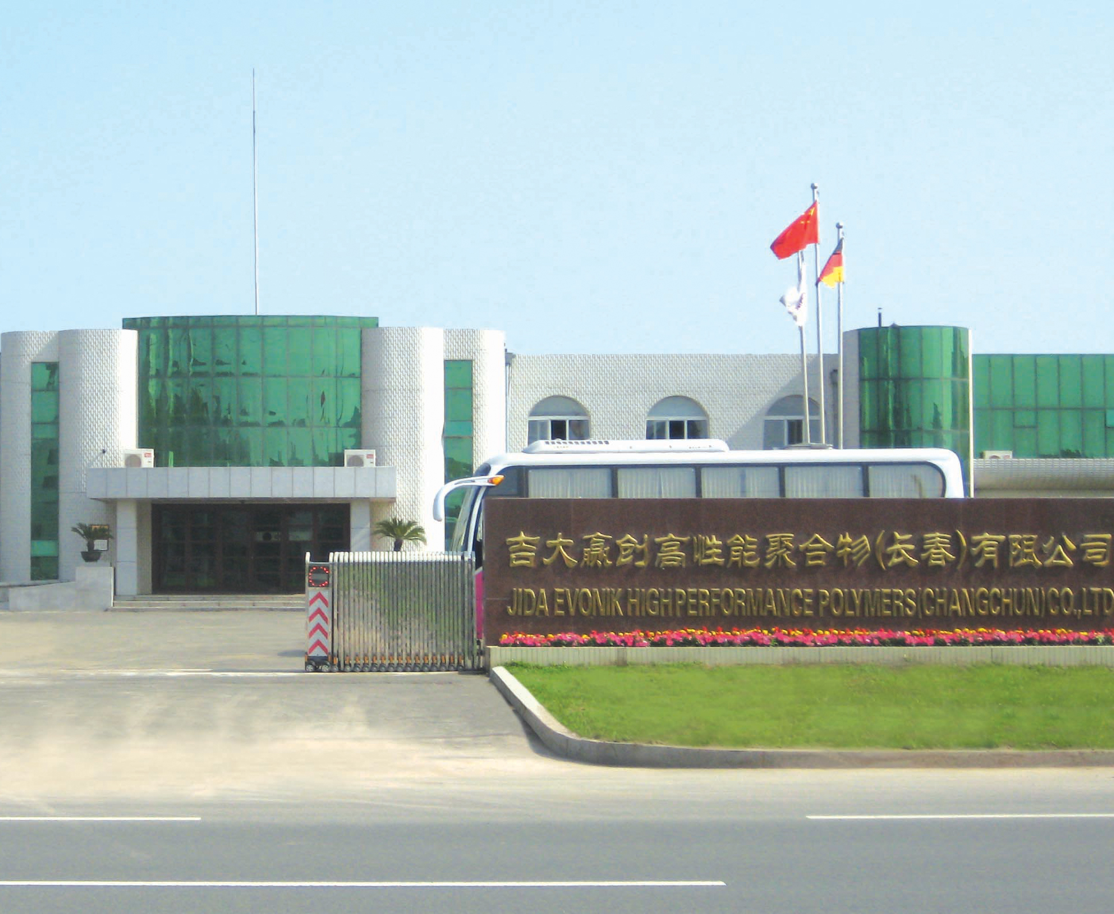

Information about Evonik

Evonik Industries is the creative industrial group from Germany. We are a global leader in our core business of specialty chemicals. In addition, Evonik is an expert in power generation from hard coal and renewable energies, and one of the largest private residential real estate companies in Germany. Our company’s performance is shaped by creativity, specialization, continuous self-renewal, and reliability.

Evonik is active in over 100 countries around the world. In its fiscal year 2009 about 39,000 employees generated sales of about €13.1 billion and an operating profit (EBITDA) of about €2.0 billion.

Disclaimer
In so far as forecasts or expectations are expressed in this press release or where our statements concern the future, these forecasts, expectations or statements may involve known or unknown risks and uncertainties. Actual results or developments may vary, depending on changes in the operating environment. Neither Evonik Industries AG nor its group companies assume an obligation to update the forecasts, expectations or statements contained in this release.

