VESTAKEEP® PEEK Films: High Performance with Minimal Wall Thickness
October 27, 2010

Dr. Ursula Keil
Marketing Support High Performance Polymers
Phone +49 2365 49-9878
Fax +49 2365 49-809878
ursula.keil@evonik.com

In addition to its extensive range of granulates and powders, Essen, Germany-based Evonik Industries now also offers polyetheretherketone (PEEK) polymers as films. VESTAKEEP® PEEK film is highly resistant to chemicals, featuring very high mechanical and flame resistance; it is stable even at continuous working temperatures and has excellent tribological and electrical properties. Evonik offers suitably adapted crystalline and amorphous VESTAKEEP® films for all sectors of industry, including medical applications.

This area has also produced the first field of application for the film, for which chemical resistance to the metal lithium was required: thin-walled insulators used to house lithium batteries in pacemakers. These insulators cannot be produced by injection molding because of their thin wall thicknesses and long flow paths. Welch Fluorocarbon, a company based in Dover, New Hampshire, USA, which specializes in producing precision parts through the thermoforming of films, developed a process that builds on a specially developed VESTAKEEP® PEEK film. The film is unusually low-stress and, in contrast to conventional extruded films, hardly flows at all on melting. This is the only way possible to achieve wall thicknesses of less than 25 µm and comply with the low wall thickness tolerances required for the battery insulators.

PEEK films are the material of choice when there is a risk of damage due to elevated temperatures, contact with aggressive chemicals, or considerable mechanical stress. Applications include, for example, electrical insulators, component carriers, or components for abrasion protection. VESTAKEEP® films can be cut using standard processes and molded. Evonik provides a range of different types of films optimized to provide maximum load capacity, especially good workability and use in medical technology.

Caption:
VESTAKEEP® PEEK films can be used to manufacture three-dimensional parts with ultra-thin thermoplastic walls (25–190 µm).

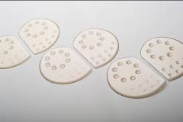
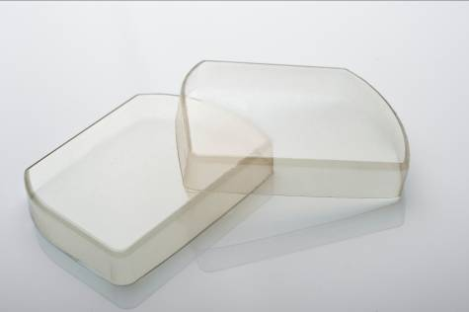

Exceptional solutions in plastics are no exception for us
Working together with its customers and partners, Evonik develops products and system solutions for and with plastics. We thus have a range of services that satisfies market and application requirements.

Evonik is present in all major growth markets around the globe. Its customized products and solutions include raw materials, sophisticated additives and paints, engineering plastics, high-performance polymers, and semi-finished products. They are virtually exactly what is needed for tomorrow’s efficient, sustainable, and environmentally friendly ideas.

About Evonik
Evonik Industries is the creative industrial group from Germany. In our core business of specialty chemicals, we are a global leader. In addition, Evonik is an expert in power generation from hard coal and renewable energies, and one of the largest private residential real estate companies in Germany. Our company’s performance is shaped by creativity, specialization, continuous self-renewal, and reliability.

Evonik is active in over 100 countries around the world. In its fiscal year 2009 about 39,000 employees generated sales of about €13.1 billion and an operating profit (EBITDA) of about €2.0 billion.

Disclaimer
In so far as forecasts or expectations are expressed in this press release or where our statements concern the future, these forecasts, expectations or statements may involve known or unknown risks and uncertainties. Actual results or developments may vary, depending on changes in the operating environment. Neither Evonik Industries AG nor its group companies assume an obligation to update the forecasts, expectations or statements contained in this release.

