Unbeatable: Evonik and APT Europe GmbH to team up in semifinished PEEK products
September 2, 2010

Dr. Ursula Keil
Marketing Support High Performance Polymers
Phone +49 2365-49-9878
Fax +49 2365-49-809878
ursula.keil@evonik.com

Evonik Degussa GmbH and APT Europe GmbH have agreed to cooperate in the manufacture and distribution of VESTAKEEP® products. In the future, APT Europe will exclusively use VESTAKEEP® PEEK by Evonik as a source material for the production of its semifinished APT PEEK products. While Evonik can offer a sales and technical service network established for decades, APT Europe has extensive expertise in the production of high-performance semifinished products made of polyether ether ketone in the USA.

The combination of the product quality of VESTAKEEP® molding compounds with the special manufacturing procedures of APT Europe offer essential ductility benefits to customers. In particular, the cooperation ensures top quality and a competitive edge for applications in the high-tech industry and in medical technology. The focus of the cooperation will be on the shared development of new applications that utilize the extraordinary performance properties of the semifinished products, for example, in medical technology.

“Thanks to the cooperation with APT Europe, we can now expand our partnership established in the U.S. to Europe,” commented Dirk Heinrich, director of Marketing & Sales for VESTAKEEP®. “As a result, we’ll be able to offer our European customers essential advantages with regard to the product quality and supply security of semifinished products based on VESTAKEEP®.” The shared product portfolio will also include the latest generation of semifinished PEEK products made with VESTAKEEP® 5000 G, which stands out for their increased ductility.

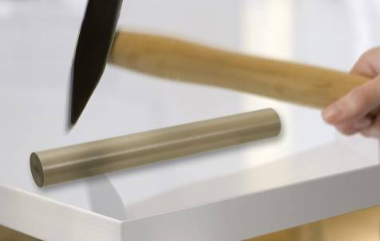
Caption:
Simply unbeatable:
new semifinished PEEK products
made with VESTAKEEP® 5000 G.

Company information

Evonik Industries is the creative industrial group from Germany. In our core business of specialty chemicals, we are a global leader. In addition, Evonik is an expert in power generation from hard coal and renewable energies, and one of the largest private residential real estate companies in Germany. Our company’s performance is shaped by creativity, specialization, continuous self-renewal, and reliability.

Evonik is active in over 100 countries around the world. In its fiscal year 2009 about 39,000 employees generated sales of about €13.1 billion and an operating profit (EBITDA) of about €2.0 billion.

Disclaimer
In so far as forecasts or expectations are expressed in this press release or where our statements concern the future, these forecasts, expectations or statements may involve known or unknown risks and uncertainties. Actual results or developments may vary, depending on changes in the operating environment. Neither Evonik Industries AG nor its group companies assume an obligation to update the forecasts, expectations or statements contained in this release.

