
VESTAKEEP® Film Protects Pacemaker Batteries
March 23, 2010

Dr. Ursula Keil
Marketing Support
Phone +49 2365 49-9878
Fax +49 2365 49-809878
ursula.keil@evonik.com

Welch Fluorocarbon and Evonik Industries Develop New Battery Insulators

High-performance batteries enhance the quality of life of pacemaker patients substantially. Because of space restrictions in pacemakers, battery insulator must be precisely tailored and as thin-walled as possible. To produce this protective liner, Welch Fluorocarbon, a company based in Dover, New Hampshire, USA, has now developed a unique process using a VESTAKEEP® polyetheretherketone (PEEK) film from Evonik Industries.

Earlier generations of pacemakers were fitted with batteries that had to be recharged daily. Only with the advent of high-performance batteries, however, were patients relieved of this considerable burden. Following a period when even plutonium-based radionuclide batteries were used, pacemakers are now fitted almost exclusively with top-capacity lithium iodine batteries, which power the pacemaker for up to ten years. These must be accommodated in the confined spaced of the pacemaker. The space available for the insulation is also very limited, and wall thickness tolerances are low. For this reason, the batteries have so far been encapsulated manually with considerable effort using polyimide adhesive strips or parylene conformal coatings.

Custom-fit insulators are an alternative, but they usually cannot be produced by injection molding because of their thin wall thicknesses, low tolerances, and long flow paths. The company Welch Fluorocarbon has now developed a unique thermoforming process that makes it possible to manufacture such components. A plastic film is fixed in a frame, melted completely by heating to a temperature above the crystalline melt point of 340 °C, and then molded in vacuum. This molding from the melt produces particularly low-stress molded parts.

Because the insulator material must be chemically resistant to metallic lithium, the choice of suitable polymers is rather restricted. Welch decided on an amorphous VESTAKEEP® PEEK film from Evonik, which both companies developed in close collaboration. The film is unusually low-stress and, in contrast to conventional extruded films, hardly flows
at all on melting. Only in this way is it possible to comply with the low thickness tolerances required. Using this film, Welch Fluorocarbon is now producing battery insulators with wall thicknesses of less than 25 microns and at extremely low tolerances.

VESTAKEEP® film is highly resistant to chemicals and also features very high mechanical and flame resistance; it is stable even at high continuous working temperatures, and has excellent tribological and electrical properties. Evonik offers suitably adapted crystalline and amorphous VESTAKEEP® films for all sectors of industry, including medical applications.

Figure caption: Three-dimensional parts with ultra-thin thermoplastic walls (25 – 190 microns) for applications where real estate is at a premium. (The high-res images are available at www.vestakeep.com)

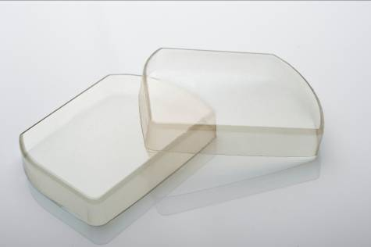

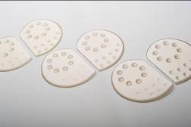

Company information
Evonik Industries is the creative industrial group from Germany which operates in three business areas: Chemicals, Energy and Real Estate. Evonik is a global leader in specialty chemicals, an expert in power generation from hard coal and renewable energies, and one of the largest private residential real estate companies in Germany. Our strengths are creativity, specialization, continuous self-renewal, and reliability. Evonik is active in over 100 countries around the world. In its fiscal year 2008 about 41,000 employees generated sales of about €15.9 billion and an operating profit (EBITDA) of about €2.2 billion.

Disclaimer

In so far as forecasts or expectations are expressed in this press release or where our statements concern the future, these forecasts, expectations or statements may involve known or unknown risks and uncertainties. Actual results or developments may vary, depending on changes in the operating environment. Neither Evonik Industries AG nor its group companies assume an obligation to update the forecasts, expectations or statements contained in this release.

