VESTAKEEP® PEEK for ball sockets combines high-temperature stability with excellent tribological properties
March 17, 2010

Dr. Ursula Keil
Marketing Support
Phone +49 2365 49-9878
Fax +49 2365 49-809878
ursula.keil@evonik.com

VESTAKEEP® PEEK, made by Essen, Germany-based Evonik Industries, dramatically reduces not only friction in ball bearings. A Japanese automotive supplier has now found that it minimizes torque and thus significantly reduces component weight, too.

VESTAKEEP® is a high-temperature polymer with a melting point of 340°C and a continuous working temperature of 250°C. VESTAKEEP® components can thus be overmolded with die-cast aluminum without any damage to the thermoplastic parts. What’s more, the excellent tribological properties are particularly advantageous in the bearings and gears of transmission systems. For these wear-resistant parts, Evonik recommends, for example, VESTAKEEP® 2000CF30, which is a medium viscous, 30% carbon fiber-reinforced compound.

As a polyetheretherketone (PEEK), VESTAKEEP® possesses outstanding chemical resistance, and parts made from it have high strength and hardness.

Figure caption: Stabilizers with VESTAKEEP® ball sockets reduce friction and thus torque.

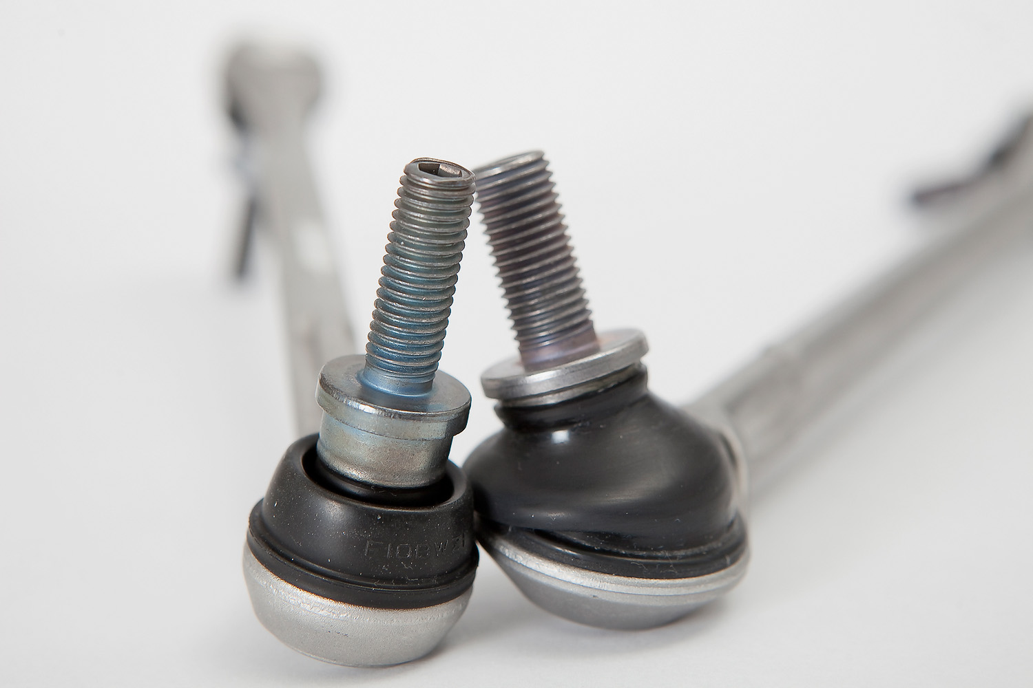

Company information
Evonik Industries is the creative industrial group from Germany which operates in three business areas: Chemicals, Energy and Real Estate. Evonik is a global leader in specialty chemicals, an expert in power generation from hard coal and renewable energies, and one of the largest private residential real estate companies in Germany. Our strengths are creativity, specialization, continuous self-renewal, and reliability. Evonik is active in over 100 countries around the world. In its fiscal year 2008 about 41,000 employees generated sales of about €15.9 billion and an operating profit (EBITDA) of about €2.2 billion.

Disclaimer

In so far as forecasts or expectations are expressed in this press release or where our statements concern the future, these forecasts, expectations or statements may involve known or unknown risks and uncertainties. Actual results or developments may vary, depending on changes in the operating environment. Neither Evonik Industries AG nor its group companies assume an obligation to update the forecasts, expectations or statements contained in this release.

