VESTAKEEP® PEEK: A High-Performance Plastic for Technologies of the Future
October 13, 2009

Dr. Ursula Keil
Marketing Support High Performance Polymers
Phone +49 2365-49-9878
Fax +49 2365-49-5992
ursula.keil@evonik.com

Over the past two years, Essen, Germany-based Evonik Industries has amassed extensive experience with its then newly launched PEEK polymers VESTAKEEP® and has introduced market-ready solutions. “Because our products have now achieved top quality worldwide, more and more customers are turning to us as a reliable alternative supplier,” says Dirk Heinrich, global director Marketing & Sales VESTAKEEP®. The product portfolio ranges from the basic polymers to specialty compounds for the cable industry or medical technology, for instance, and contains not only granulates, but a range of powders suitable for flame-spraying or for manufacturing composites, as well as PEEK-based films and tapes that can be used to minimize wear between the steel reinforcements in oil transport pipelines. It can also be produced as a fiber.

A product for a variety of applications
Evonik has established itself as an expert partner in the PEEK business and initiated promising developments with renowned companies in the electronics, automotive, and mechanical engineering industries. Customers from America, Asia, and Europe show an avid interest in all of the relevant applications for the high-temperature polymers of the VESTAKEEP® PEEK family of products:

VESTAKEEP® in the semiconductor industry
Innodis Ltd., a Korean company, has released VESTAKEEP® 4000G black for five models of semiconductor (LCD guide rollers). VESTAKEEP® withstands the harsh conditions of LCD production, which are similar to those of semiconductor production, with deposition, photolithography, and etching at extremely high process temperatures. Because of the extreme purity of the material, the rollers do not damage or contaminate the filigree surface.

Metal substitution: from solid rod to bearing
Houston-based Vertec Polymers, specializing in polymer formulations for wear and structural applications, is using the high-performance polymer VESTAKEEP® PEEK in its new Vertec 5025 solid rod. The rod is used to manufacture bearings that can replace lubricated metal bearings. The decisive factor in the selection of VESTAKEEP® was the special tribological property profile of the high-temperature polymer, which greatly reduces the need for maintenance and lubrication for bearings made from this material. Vertec 5025 bearings are also lighter, more durable, and exhibit minimal counter-surface wear.

Metal substitute: in gear units, drives and motors
VESTAKEEP® PEEK outperforms metals by improving system durability and reducing component manufacturing cost. These benefits are derived from a superior combination of corrosion resistance, abrasion resistance, strength-to-weight attributes, and processing versatility. Use of PEEK eliminates corrosion due to salts, solvents, caustics and many acids, and also reduces abrasive wear due to slurries, particulate impact, and moving surfaces. These properties have allowed PEEK to outperform aluminum, titanium, and steel in such applications as aircraft engines and bushings in the mining, pulp and paper industries. Pound for pound, PEEK has a higher strength-to-weight ratio than aluminum or zinc. Lower-mass parts provide fuel savings in transport, improved durability in compressor components, and more efficient engine design for gears and impellers. Replacing metals with VESTAKEEP® PEEK reduces component cost due to improved durability, efficient processing methods, part consolidation, and increased design freedom.

VESTAKEEP® polymers for medical applications
In general, PEEK is used in medical products to improve their usefulness: lighter weight, more freedom of design, and better functional integration. It’s also an inexpensive alternative to metals and other materials. Its performance is distinguished by biocompatibility, chemical resistance, resistance to gamma rays or X-rays, as well as X-ray transparency, outstanding resistance to hot-steam sterilization, high mechanical strength, and wear and impact resistance, good electrical insulation properties, and good hydrolysis resistance. Evonik offers two grades of VESTAKEEP® for medical applications. Which one ought to be used depends on what kind of contact it’ll have with the body, and for how long. In our product nomenclature, “M” stands for short-term contact, and “I” for long-term contact. Information on the VESTAKEEP® I range has been filed with the Food and Drug Administration (FDA) of the United States in a device master file, which makes it easier for Evonik's customers to obtain approval for implant products.

Composites with a thermoplastic matrix
VESTAKEEP® fine powders are suitable for production of composites for the aerospace industry, as well as for the oil and gas industries. Currently, Evonik is quickly becoming a key supply-chain partner worldwide to manufacturers that use these powders to make composite UD-tapes, fabric-based prepregs, and laminates. VESTAKEEP® provides unidirectional fiber layouts for fabrics made of glass, carbon, or aramid fibers with a matrix, making it possible in turn to produce fiber composites with a thermoplastic matrix. The composites are coated by means of a powder-coating or dispersion-coating process. Evonik has developed powder grades especially suitable for these processes, and the VESTAKEEP® 2000 powder line, with its different particle sizes, has earned a reputation as an ideal polymer for this application. Fiber-reinforced composites with VESTAKEEP® PEEK offer considerable mechanical properties, outstanding stabilization, and high chemical resistance.

Flame spraying
VESTAKEEP® PEEK powders can be used to coat metals efficiently. Recently, the company concluded an agreement with IBEDA Sicherheitsgeräte und Gastechnik GmbH & Co. KG that will offer customers a complete solution for coating with the metal-spray process. The mobile IBEDA plastic flame-spraying system F311 FX-S makes it possible to coat large work pieces without an oven, at low cost, and with low material consumption. VESTAKEEP® coatings applied by means of this process yield extremely wear-resistant surfaces with outstanding chemical resistance.

Analytics with VESTAKEEP®
Tomoe Works Co., Ltd., a Japanese company that develops, manufactures, and sells columns for liquid chromatography, adopted VESTAKEEP® PEEK as the material for its analytical column pipes and plugs. Tomoe Works recognized the advantages that PEEK provides through application to analytical columns, and has thus become a leading domestic developer and producer of columns, plugs, and filters made from PEEK, as well as functional metal parts. VESTAKEEP® is noted for its high pressure resistance, which is a key feature required of any analytical column material, while its dimensional stability has received great praise.

Added value through excellence
All information on VESTAKEEP®, its applications, and our expertise can be found at our website, which was recently relaunched: www.vestakeep.com.

Evonik supplies VESTAKEEP® PEEK as fine powders for composites, for compression molding and coatings, as well as granules for compounding, injection-molding, and extruding systems. In addition to unfilled products, reinforced grades are available to improve cyclic fatigue performance, modulus, and abrasion resistance. Tribological grades are available to reduce friction and wear. VESTAKEEP® films and tapes are also available.

Evonik has been successfully producing and marketing high-performance polymers for more than 40 years and is highly regarded in the market for its experience in application technology. The company has successfully applied its expertise in injection molding, extrusion, compression molding, and CAE (computer-aided engineering) analysis to the VESTAKEEP® products, which were introduced into the product portfolio in 2007 and made available to Evonik’s newly acquired development partners. The cooperation is long-term and also includes longer accreditation periods.

Subject | Image | Figure caption
Semiconductor industry | 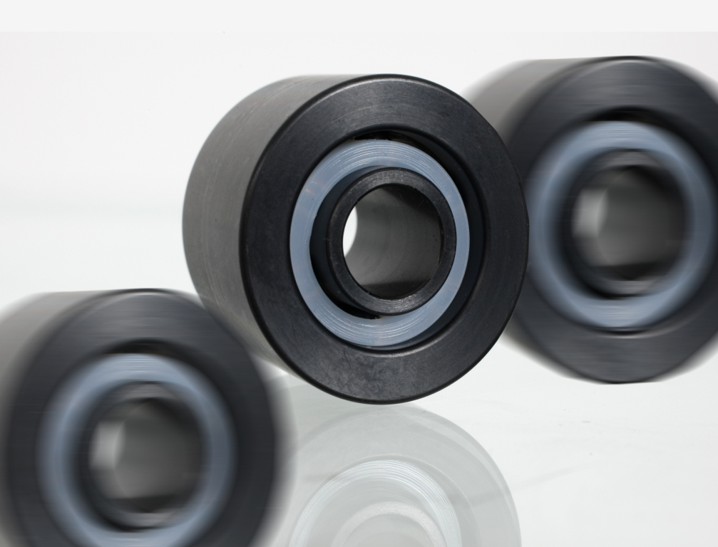 | Thanks to its extraordinary high chemical resistance and heat resistance (HDT 260°C), wear resistance and mechanical properties, Innodis Ltd. has adopted VESTAKEEP® PEEK for five of its semiconductor models.
Solid rod | 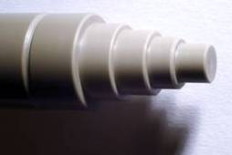 | The use of VESTAKEEP® PEEK in Vertec 5025 rods significantly reduces the maintenance and lubrication for bearings produced from it.
Medicine | 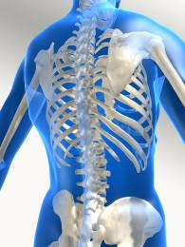 | The combination of outstanding mechanical properties and resistances with biocompatibility opens up new opportuneities for VESTAKEEP® polymers in the area of medicine. (Photo: Sebastian Kaulitzki / Fotolia.de)
Composites | 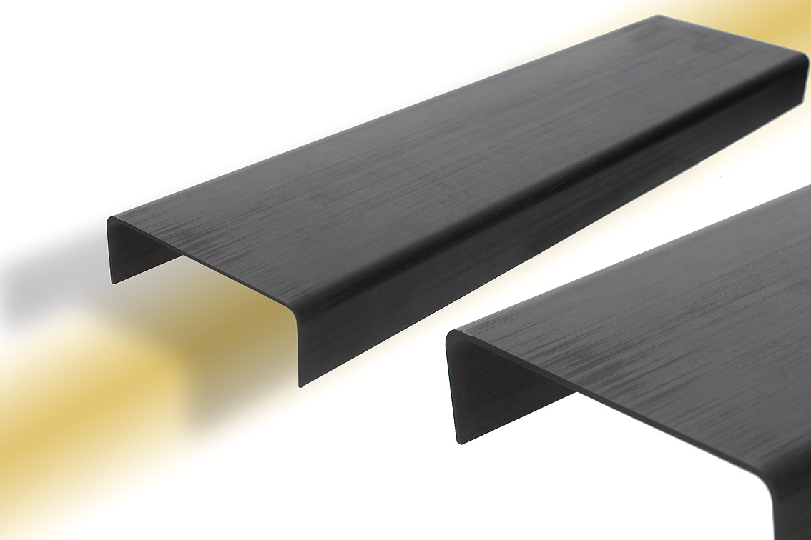 | VESTAKEEP® provides unidirectional fiber layouts for fabrics made of glass, carbon, or aramid fibers with a matrix, making it possible in turn to produce fiber composites with a thermoplastic matrix.
Flame spraying | 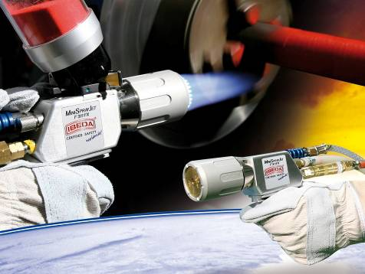 | The mobile IBEDA plastic flame-spraying system F311 FX-S allow the application of highly wear-resistant VESTAKEEP® coatings on site (photo: IBEDA).
Tapes | 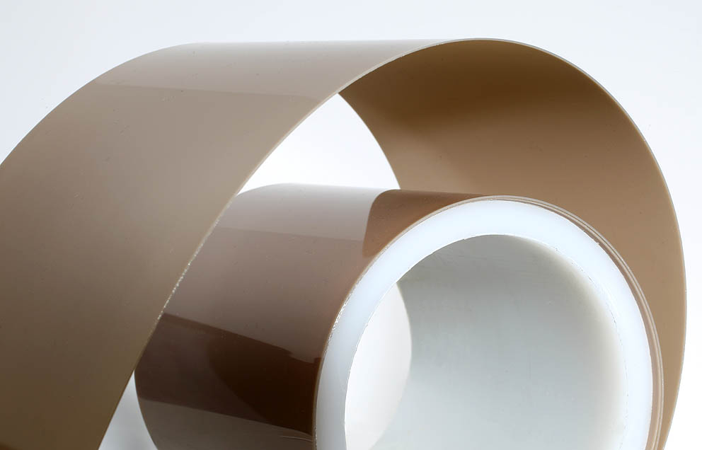 | Tapes made from VESTAKEEP® PEEK reduce the wear between the steel reinforcements in oil transport pipelines and help extend their useful life.

All photographs can be downloaded from www.vestakeep.com

Company information
Evonik Industries is the creative industrial group from Germany which operates in three business areas: Chemicals, Energy and Real Estate. Evonik is a global leader in specialty chemicals, an expert in power generation from hard coal and renewable energies, and one of the largest private residential real estate companies in Germany. Our strengths are creativity, specialization, continuous self-renewal, and reliability. Evonik is active in over 100 countries around the world. In its fiscal year 2008 about 41,000 employees generated sales of about €15.9 billion and an operating profit (EBITDA) of about €2.2 billion.

Disclaimer

In so far as forecasts or expectations are expressed in this press release or where our statements concern the future, these forecasts, expectations or statements may involve known or unknown risks and uncertainties. Actual results or developments may vary, depending on changes in the operating environment. Neither Evonik Industries AG nor its group companies assume an obligation to update the forecasts, expectations or statements contained in this release.

