Persists in harsh environment: Innodis Ltd adopted VESTAKEEP® PEEK for semiconductor bearings
May 18, 2009

Dr. Ursula Keil
Marketing Support
Phone +49 2365 49-9878
Fax +49 2365 49-5992
ursula.keil@evonik.com

The high-performance polymer VESTAKEEP® 4000G black of Essen, Germany-based Evonik Industries has proven its extraordinary chemical resistance in a harsh environment: Due to its additional heat resistance (HDT 260°C), wear resistance and mechanical properties Innodis Ltd adopted the polyetheretherketone (PEEK) compound for five new models of semiconductor bearings (LCD Guide Rollers). VESTAKEEP® withstands the harsh processing conditions of the LCD which are similar to those of semiconductor production with deposition, photolithography and etching at extremely high processing temperatures.

The LCD glass plates are heated in a vacuum chamber and source gas is introduced to prepare for plasma coating. During coating, structuring and etching, the LCD guide rollers made from VESTAKEEP® PEEK have to withstand the tough ambient conditions on the one hand, and on the other hand does not contaminate or destroy the filigree top layer on the glass due to the high pureness of the material.

Low extractables, outgassing, and contaminates make VESTAKEEP® an excellent material for wafer handling in semiconductor manufacturing processes. PEEK has excellent oxidative stability in the melt and can be used continuously at temperatures exceeding 220°C (dynamic stressed 180°C). Compared to other plastics, PEEK provides the best combination of inertness and heat resistance. VESTAKEEP® retains original properties after long-term exposure to steam, ethylene oxide, and gamma radiation. Therefore, the VESTAKEEP® PEEK compounds are best suited for manufacturing components for long-term use in harsh environments. These parts are found, e.g., in the semiconductor processing, oil exploration, industrial, transport, and medical markets.

VESTAKEEP® PEEK outperforms metals by improving system durability and reducing component manufacturing cost. These benefits are derived from a superior combination of corrosion resistance, abrasion resistance, strength-to-weight attributes, and processing versatility. Use of PEEK eliminates corrosion due to salts, solvents, caustics, and many acids and also reduces abrasive wear due to slurries, particulate impact, and moving surfaces. These properties have allowed PEEK to outperform aluminum, titanium, and steel in air impellers in aircraft, in bushings in mining, pulp, and paper industries. Pound-for-pound, PEEK has a higher strength-to-weight ratio than aluminium and zinc. Lower mass parts provide fuel savings in transport, improved durability in compressor components, and more efficient motor design for gears and impellers. Replacing metals with VESTAKEEP® PEEK reduces component cost due to improved durability, efficient processing methods, part consolidation, and increased design freedom over machined metals.

Evonik provides VESTAKEEP® PEEK resins in fine powders for composites, compression molding, and coatings as well as granules for compounding, injection molding and extrusion. In addition to unfilled products reinforced grades are available to improve cyclic fatigue performance, modulus, and abrasion resistance. Tribological grades are available to reduce friction and wear.

Evonik has been successfully producing and marketing high-performance polymers for more than 40 years, and is highly valued in the market for its experience in application technology. The company has successfully applied its expertise in injection molding, extrusion, compression molding, and CAE (Computer-Aided Engineering) analysis to the VESTAKEEP® compounds, which were introduced into the product portfolio in 2007 and made available to Evonik’s newly acquired development partners. The collaboration is designed on the basis of a long-term partnership, which also allows for fairly long accreditation periods.

Innodis Co. Ltd is a leading manufacturer for the precision parts in Semiconductor manufacturing process (bath, valve, wafer guide), LCD manufacturing process (gear, shaft) and Industrial machineries.

Figure caption:
Due to its outstanding chemical and heat resistance (HDT 260°C), wear resistance and mechanical properties Innodis Ltd adopted VESTAKEEP® PEEK for five new models of semiconductor bearings (LCD Guide Rollers).

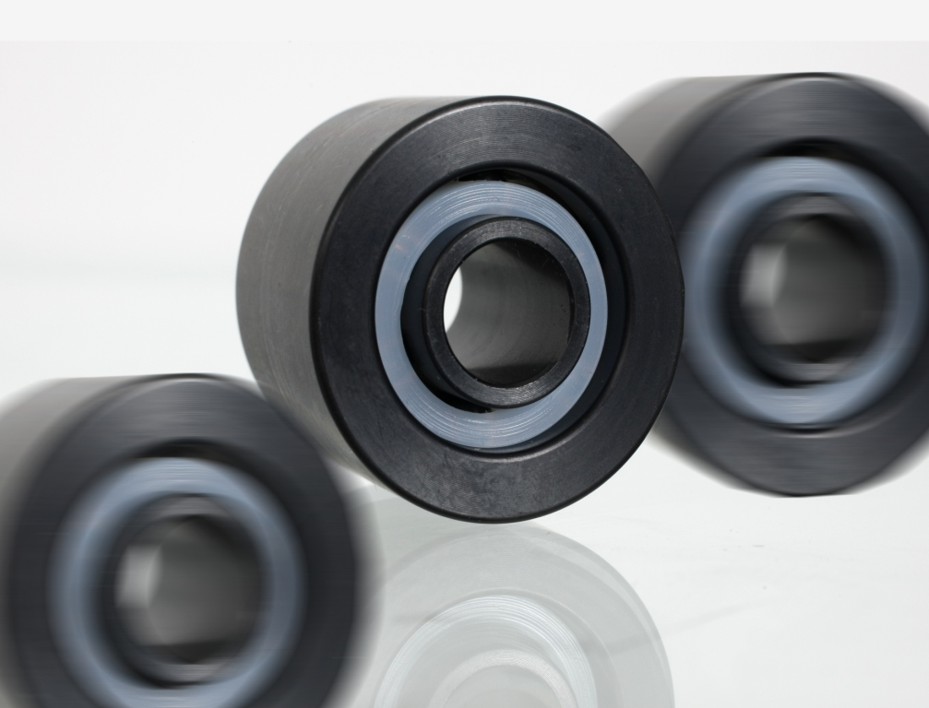

Company information
Evonik Industries is the creative industrial group from Germany which operates in three business areas: Chemicals, Energy and Real Estate. Evonik is a global leader in specialty chemicals, an expert in power generation from hard coal and renewable energies, and one of the largest private residential real estate companies in Germany. Our strengths are creativity, specialization, continuous self-renewal, and reliability. Evonik is active in over 100 countries around the world. In its fiscal year 2008 about 41,000 employees generated sales of about €15.9 billion and an operating profit (EBITDA) of about €2.2 billion.

Disclaimer
In so far as forecasts or expectations are expressed in this press release or where our statements concern the future, these forecasts, expectations or statements may involve known or unknown risks and uncertainties. Actual results or developments may vary, depending on changes in the operating environment. Neither Evonik Industries AG nor its group companies assume an obligation to update the forecasts, expectations or statements contained in this release.

