Evonik Effectually Established As New Partner in PEEK Business
December 12, 2008

Dr. Ursula Keil
Marketing Support
Phone +49 2365 49-9878
Fax +49 2365 49-5992
ursula.keil@evonik.com

Confident About VESTAKEEP® for 2009

Evonik Industries, Essen, has established itself over the last year as an expert partner in the PEEK business. In collaboration with well-known companies in the electronics, automotive, and machinery industries, Evonik has initiated further promising developments using its high-grade VESTAKEEP® compounds. Customers from North America, Asia, and Europe are keenly interested in the amazing VESTAKEEP® specialty chemical products, which are used in all applications relevant to these high-temperature polymers.

“VESTAKEEP met all of our expectations in 2008. Despite the generally difficult economic climate, we're looking forward confidently to 2009,” says Dirk Heinrich, Global Director Marketing & Sales for VESTAKEEP®, of the current situation. “Our quality has been accepted on a broad front; promising projects have been initiated in all the usual application segments; and we've further strengthened our excellent PEEK team. We aim to shape and dominate the PEEK market over the long term.”

Evonik has been successfully producing and marketing high-performance polymers for more than 40 years, and is highly valued in the market for its experience in application technology. The specialty chemicals company has successfully applied its expertise in injection molding, extrusion, compression molding, and CAE (Computer-Aided Engineering) analysis to the VESTAKEEP® compounds, which were introduced into the product portfolio in 2007 and made available to Evonik’s newly acquired development partners. The collaboration is designed on the basis of a long-term partnership, which also allows for fairly long accreditation periods.

Like other high-performance polymers from Evonik, all VESTAKEEP® compounds and powders are regulated by the quality management system, which has ISO 9001:2000 and ISO/TS 16949:2002 certification, and satisfy the usual quality standards.

Figure caption:
Fiber composite materials produced from VESTAKEEP® with unidirectional fiber layers or fabrics of glass, carbon, or aramid fibers offer valuable physical properties and high chemical resistance.



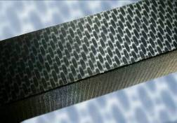

Figure caption:
VESTAKEEP® allows excellent reproduction, even of microstructures.

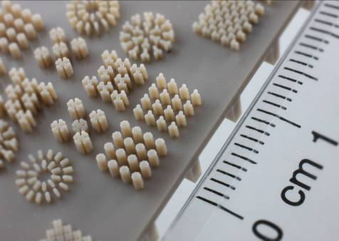

Company information
Evonik Industries is the creative industrial group from Germany which operates in three business areas: Chemicals, Energy and Real Estate. Evonik is a global leader in specialty chemicals, an expert in power generation from hard coal and renewable energies, and one of the largest private residential real estate companies in Germany. Our strengths are creativity, specialization, continuous self-renewal, and reliability. Evonik is active in over 100 countries around the world. In its fiscal year 2007 about 43,000 employees generated sales of about €14.4 billion and an operating profit (EBITDA) of more than €2.2 billion.

Disclaimer
In so far as forecasts or expectations are expressed in this press release or where our statements concern the future, these forecasts, expectations or statements may involve known or unknown risks and uncertainties. Actual results or developments may vary, depending on changes in the operating environment. Neither Evonik Industries AG nor its group companies assume an obligation to update the forecasts, expectations or statements contained in this release.

