More Sophisticated, Lighter, and Greater Design Freedom
August 22, 2008

Dr. Ursula Keil
Performance Polymers
Phone +49 2365 49-9878
Fax +49 2365 49-5992
ursula.keil@evonik.com

Evonik to present its system solutions expertise at FAKUMA 2008

Evonik Industries will participate in FAKUMA 2008 in Friedrichshafen, showcasing more sophisticated optics in headlights and displays, greater design freedom, and further weight reduction in the automotive field. At Booth 4117 in Hall A4, it will present customized system solutions for these issues.

Evonik offers, for example, a new polymethyl methacrylimide (PMMI) with optimized optical properties, especially suitable for automotive headlight optics. Tests have proven that the new product, named PLEXIMID®, has light transmission of more than 90 percent even after being subjected to a temperature of 150°C continuously over a period of more than 40 days. PLEXIGLAS® SuPure, another novel product from Evonik, satisfies the tighter purity requirements for particularly high-grade transparent applications in the area of display covers.

Also new is VESTAMID® HTplus, a polyphthalamide (PPA) based material that is stable at high temperatures. This has been specially developed as a substitute for metal in typical metal applications and offers decisive system advantages in terms of weight reduction and design freedom. On the basis of its many years of expertise in plastic-rubber composites that do not require adhesion promoters, Evonik has already developed PPA molding compounds that can be directly bonded to H-NBR and FKM rubber.

With its high-temperature polymer VESTAKEEP® PEEK, the creative industrial group offers a material with high application potential, thanks to its long-term high-temperature stability, for example. In cable sheathing, for example, VESTAKEEP® simultaneously fulfils three functions, serving as heat shield as well as for insulation and abrasion protection. Thanks to its special tribological properties the material can, for example, replace lubricated metal bearings, which considerably reduces maintenance and lubrication requirements.

The POLYTREND® liquid color system likewise offers the plastics industry the greatest possible flexibility in color selection. With specified equipment and a clearly defined choice of base colors, inline coloring has become simple. The ease and rapidity of inline color change using the POLYTREND® liquid color system will be demonstrated at the tradeshow booth.

Figure captions:

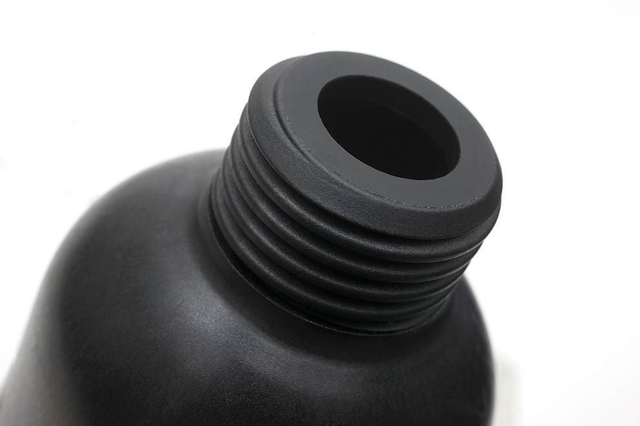

Due to the excellent mechanical properties molds made from VESTAMID® HTplus can replace metal parts.

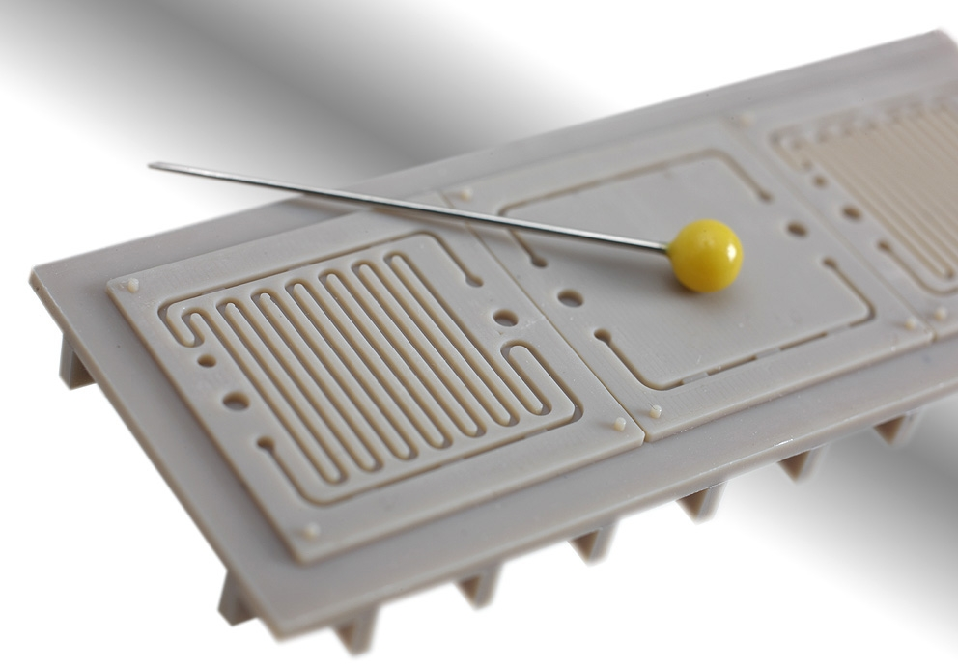
VESTAKEEP® allows excellent reproduction, even of microstructures.

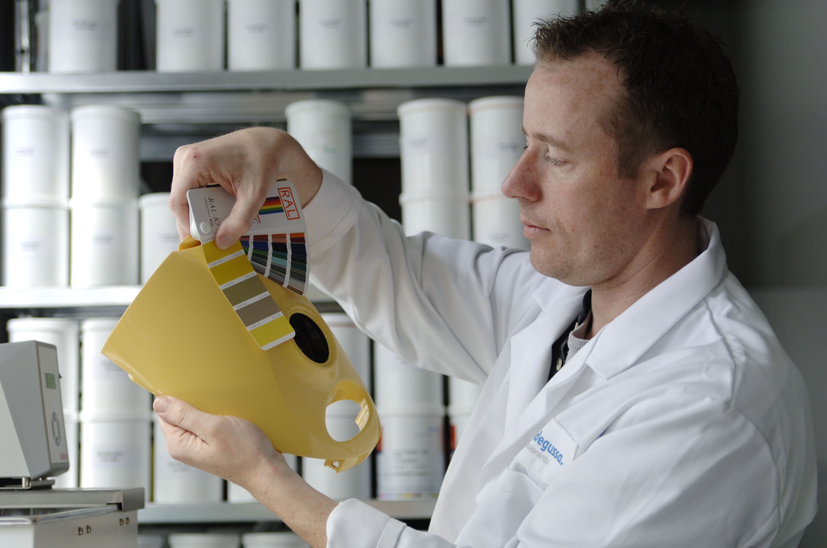

The POLYTREND® liquid color system allows easy implementation of new color formulations.

The photos can be downloaded from www.evonik.com/hp

The Performance Polymers Business Unit of Evonik Industries is a worldwide manufacturer of PMMA products sold under the PLEXIGLAS® trademark on the European, Asian, African and Australian continents and under the trademark ACRYLITE® in the Americas.

Company information
Evonik Industries is the creative industrial group from Germany which operates in three business areas: Chemicals, Energy and Real Estate. Evonik is a global leader in specialty chemicals, an expert in power generation from hard coal and renewable energies, and one of the largest private residential real estate companies in Germany. Our strengths are creativity, specialization, continuous self-renewal, and reliability. Evonik is active in over 100 countries around the world. In its fiscal year 2007 about 43,000 employees generated sales of about €14.4 billion and an operating profit (EBIT) of more than €1.3.

Disclaimer
In so far as forecasts or expectations are expressed in this press release or where our statements concern the future, these forecasts, expectations or statements may involve known or unknown risks and uncertainties. Actual results or developments may vary, depending on changes in the operating environment. Neither Evonik Industries AG nor its group companies assume an obligation to update the forecasts, expectations or statements contained in this release.

