High precision screws made from VESTAKEEP® PEEK
March 11, 2015

Thomas Lange
Contact specialized press
High Performance Polymers
Phone +49 2365-49-9227
thomas.lange2@evonik.com

Evonik Industries AG
Rellinghauser Straße 1-11
45128 Essen
Germany
Phone +49 201 177-01
Fax +49 201 177-3475
www.evonik.com
www.vestakeep.com

Chairman of the Supervisory Board
Dr. Werner Müller
Executive Board
Dr. Klaus Engel, Chairman
Christian Kullmann
Thomas Wessel
Patrik Wohlhauser
Dr. Uwe Wolf

Registered Office: Essen
Register Court: Essen Local Court
Commercial Registry B 19474
VAT ID no. DE 811160003
- For application in the semiconductor and pharmaceutical industries

Nippon Chemical Screw & Co, headquartered in Japan, recently approved VESTAKEEP® for the manufacture of high precision one-inch sized screws. VESTAKEEP® is the trade name of Evonik Industries for high temperature polymer polyether ether ketone (PEEK).

The one inch-sized screw design is manufactured for various industries, especially semiconductors and pharmaceuticals, in the North American market.

Depending on the application, the VESTAKEEP® PEEK must fulfill different requirements. For example, in semiconductor manufacturing, a high purity is required. On the other hand, in pharmaceutical and food equipment sectors, the material needs to comply with drug or food contact requirements. In other typical industrial production lines, VESTAKEEP® PEEK must also satisfy many other specifications such as chemical resistance, high mechanical strength, or fatigue resistance.

Other advantages associated with VESTAKEEP® PEEK include high dimensional stability and ease of processing during injection molding processes. This leads to a very efficient and cost effective manufacturing process.

As a result, Evonik’s VESTAKEEP® PEEK is well suited for components that must withstand the toughest environmental conditions. VESTAKEEP® PEEK is now commonly found in oil exploration, automotive and aerospace industries, as well as in medical implants with VESTAKEEP® implant grades.

In North America, VESTAKEEP® PEEK screws are available through Solid Spot (Santa Clara, CA).

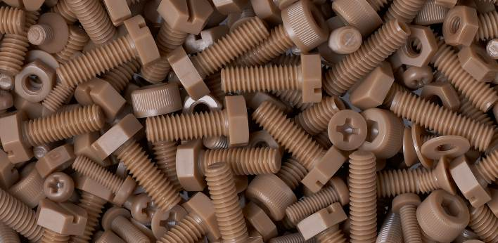
Photo caption:
Screws made from VESTAKEEP® PEEK

About Evonik
Evonik, the creative industrial group from Germany, is one of the world leaders
in specialty chemicals. Profitable growth and a sustained increase in the value of the company form the heart of Evonik’s corporate strategy. Its activities focus on the key megatrends health, nutrition, resource efficiency and globalization. Evonik benefits specifically from its innovative prowess and integrated technology platforms.

Evonik is active in over 100 countries around the world. In fiscal 2014 more than 33,000 employees generated sales of around €12.9 billion and an operating profit (adjusted EBITDA) of about €1.9 billion.

Disclaimer
In so far as forecasts or expectations are expressed in this press release or where our statements concern the future, these forecasts, expectations or statements may involve known or unknown risks and uncertainties. Actual results or developments may vary, depending on changes in the operating environment. Neither Evonik Industries AG nor its group companies assume an obligation to update the forecasts, expectations or statements contained in this release.

