March 4, 2014
Contact Europe
Thomas Lange
Telefon +49 2365 49-9227
Telefax +49 2365 49-809227
thomas.lange2@evonik.com

Contact Americas
Peter Colburn
Telefon +1 203 284-4291
Telefax +1 203 284-4298
peter.colburn@evonik.com

Evonik Industries AG
Rellinghauser Straße 1-11
45128 Essen
Germany
Phone +49 201 177-01
Telefax +49 201 177-3475
www.evonik.com
www.vestakeep.com

Supervisory Board
Dr. Werner Müller, Chairman
Executive Board
Dr. Klaus Engel, Chairman
Thomas Wessel
Patrik Wohlhauser
Ute Wolf
Registered office Essen
Registered court
Essen local court
Commercial registry B 19474
VAT ID no. DE 811160003

VESTAKEEP® PEEK 5000 G passes NORSOK M-710 test

Evonik Industries, for decades a reliable partner to the oil and gas industry, obtained NORSOK M-710 qualification for its newest generation of polyether ether ketone VESTAKEEP® PEEK 5000 G. Evonik contracted the established institute Element MERL to conduct the NORSOK M-710 Standard aging test in sour (H₂S) conditions at 1,450 psi (10 MPa) and test temperatures of 200 °C (392°F), 210 °C (410°F) and 220 °C (428°F) for up to 60 days (NORSOK M-710 revision 2).

The successful test performance proves the optimal suitability of VESTAKEEP® PEEK 5000 G for the highly demanding conditions of the oil and gas industry.

The test result summary provides the operator with the indication of a durable service temperature of 200 °C (392°F): No measurable chemical deterioration for VESTAKEEP® 5000 G appeared during that period of time, indicating that there is no degradation effect on material performance during the expected operating time.

Furthermore, customers in the oil and gas industry benefit from additional performance advantages of VESTAKEEP® 5000 G like:

- higher wear resistance

- fatigue resistance 2 to 4 times higher (depending on load)

- 15% higher pressure creep resistance than alternative PEEK materials

Currently NORSOK-M 710 rev 2 is the valid standard used in the oil and gas industry.

In order to follow the needs in the oil and gas industry and to support our customers, Evonik is presently testing VESTAKEEP® L4000 G with the NORSOK M-710 test under rev 3, which subjects the material to much harsher conditions.

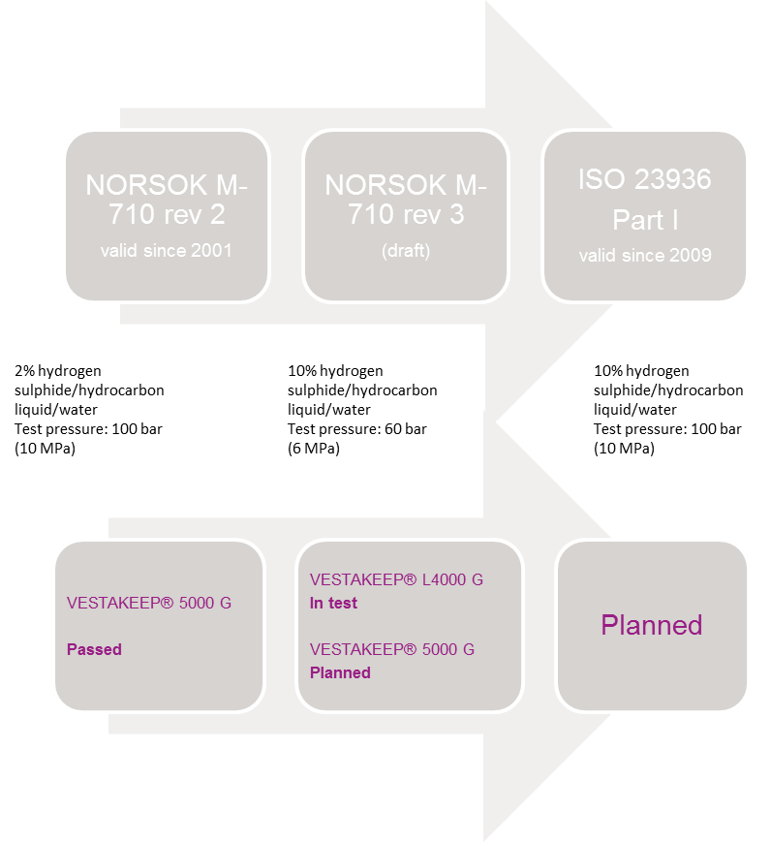

Company information
Evonik, the creative industrial group from Germany, is one of the world leaders
in specialty chemicals. Profitable growth and a sustained increase in the value of the company form the heart of Evonik’s corporate strategy. Its activities focus on the key megatrends health, nutrition, resource efficiency and globalization. Evonik benefits specifically from its innovative prowess and integrated technology platforms.

Evonik is active in over 100 countries around the world. In fiscal 2012 more than 33,000 employees generated sales of around €13.4 billion and an operating profit (adjusted EBITDA) of about €2.4 billion (excluding Real Estate in both cases).

Disclaimer
In so far as forecasts or expectations are expressed in this press release or where our statements concern the future, these forecasts, expectations or statements may involve known or unknown risks and uncertainties. Actual results or developments may vary, depending on changes in the operating environment. Neither Evonik Industries AG nor its group companies assume an obligation to update the forecasts, expectations or statements contained in this release.

