K 2013, Hall 6 Booth No. B28
October 17, 2013
Contact person specialized press
Thomas Lange
High Performance Polymers
Telefon +49 2365-49-9227
Telefax +49 2365-49-809227
thomas.lange2@evonik.com

Evonik Industries AG
Rellinghauser Straße 1-11
45128 Essen
Germany
Phone +49 201 177-01
Telefax +49 201 177-3475
www.evonik.de

Supervisory Board
Dr. Werner Müller, Chairman
Executive Board
Dr. Klaus Engel, Chairman
Dr. Thomas Haeberle,
Thomas Wessel, Patrik Wohlhauser, Ute Wolf, Dr. Dahai Yu

Registered office Essen
Registered court
Essen local court
Commercial registry B 19474
VAT ID no. DE 811160003

PEEK processing with ease:

Live extrusion demo at K-Messe

Polyether ether ketone (PEEK) is known for its ability to withstand high temperatures of over 220ºC. PEEK shaping, however, requires even higher processing temperatures of up to 420°C. Many plastic processors consider these high temperatures a major challenge for production. Evonik Industries and Bernhard Ide GmbH & Co. KG have therefore teamed up with a joint exhibit at the K-Messe in Düsseldorf to show just how easy the extrusion of PEEK can be.

PEEK extrusion has been proven for years and no longer presents any problem for trained processors. Ide will set up a live extrusion system at its tradeshow stand to demonstrate the ease of processing the material. The extruded material will be VESTAKEEP® PEEK L4000 G by Evonik.

VESTAKEEP® PEEK is 15 percent more impact-resistant than standard PEEK of the same material strength. This combination is of particular interest to suppliers of the oil and gas industry, but other industries with high technical demands will equally benefit from the properties of VESTAKEEP®.

Visit us at the K-Messe in Düsseldorf from October 16 to 23, 2013!

- Evonik Industries in Hall 6, B 28
- Bernhard Ide GmbH & Co.KG in Hall 16, F43

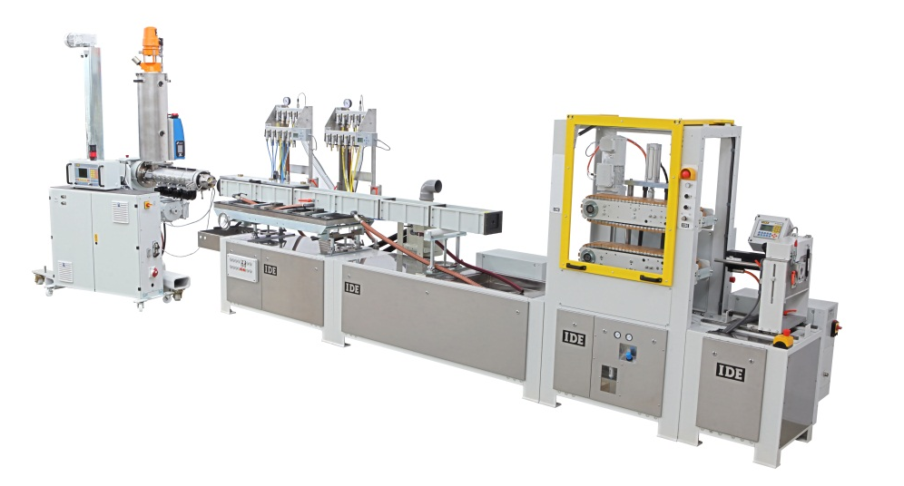

About Ide
Ide, a third-generation mid-sized family-owned business, has been an internationally recognized specialist for profile extrusion systems, tool systems, and custom solutions in the area of extrusion for over fifty years. Customers of Ide rely on the company's trade skills and process technology expertise that was developed together with them. Ide solutions for extrusion are used all over the globe.

About Evonik
Evonik, the creative industrial group from Germany, is one of the world leaders
in specialty chemicals. Profitable growth and a sustained increase in the value of the company form the heart of Evonik’s corporate strategy. Its activities focus on the key megatrends health, nutrition, resource efficiency and globalization. Evonik benefits specifically from its innovative prowess and integrated technology platforms.

Evonik is active in over 100 countries around the world. In fiscal 2012 more than 33,000 employees generated sales of around €13.4 billion and an operating profit (adjusted EBITDA) of about €2.4 billion (excluding Real Estate in both cases).

Disclaimer
In so far as forecasts or expectations are expressed in this press release or where our statements concern the future, these forecasts, expectations or statements may involve known or unknown risks and uncertainties. Actual results or developments may vary, depending on changes in the operating environment. Neither Evonik Industries AG nor its group companies assume an obligation to update the forecasts, expectations or statements contained in this release.

