November 6th, 2018

Specialized Press Contact
Janusz Berger
Communication Manager
High Performance Polymers
Phone +49 2365 49-9227
janusz.berger@evonik.com

Evonik Resource Efficiency GmbH
Rellinghauser Straße 1-11
45128 Essen
Phone +49 201 177-01
Fax +49 201 177-3475
www.evonik.com

Supervisory Board
Dr. Harald Schwager, Chairman
Managing Directors
Dr. Claus Rettig, Chairman
Dr. Johannes Ohmer
Simone Hildmann
Alexandra Schwarz

Registered Office: Essen
Register Court: Essen Local Court
Commercial Registry B 25783
VAT ID no. DE 815528487
Evonik develops the world’s first PEEK filament in implant-grade quality for 3D printing

Evonik has become the first company in the world to develop a polymer filament based on PEEK (polyether ether ketone) in implant-grade quality for use as a 3D printing material for implants. This high-performance material can be used in fused filament fabrication (FFF) technology and is expected to enable additive production of three-dimensional plastic parts for medical implants in the human body.

The new PEEK filament is based on VESTAKEEP® i4 G, a highly viscous implant-grade material made by Evonik. The product, which exhibits impressive biocompatibility, biostability, and x-ray transparency, is easy to process and has been established for years as a high-performance material in medical technology applications such as spinal implants, sports medicine, and maxillofacial surgery.

Testing grade enables cost-effective process adaptation
Evonik will additionally be offering a less expensive “testing grade” version of its PEEK filament for FFF technology. The testing-grade material has the exact same processing and mechanical product properties as the implant-grade material—but without the documentation needed for approval in medical device applications. This offers a cost-effective way of adapting the processing characteristics of the high-performance plastic for printing processes. The natural-colored filament, which has a diameter of 1.75 mm, is wound on 500 gram spools suitable for direct use in standard FFF 3D printers for PEEK materials.

In the first quarter of 2019, the testing grade will be followed by an implant-grade VESTAKEEP® i4 G, which can be provided with the required extensive approval documentation.

Broad portfolio of polymer materials for 3D printing
Development of the world’s first PEEK filament expands Evonik’s existing line of polymer materials for 3D printing. The specialty chemicals company is the world’s leading manufacturer of polyamide (PA) 12 powders, which have been used in additive production technologies for over 20 years now. In addition to the PEEK filament and PA 12 powders, the material portfolio also includes flexible PEBA powders.
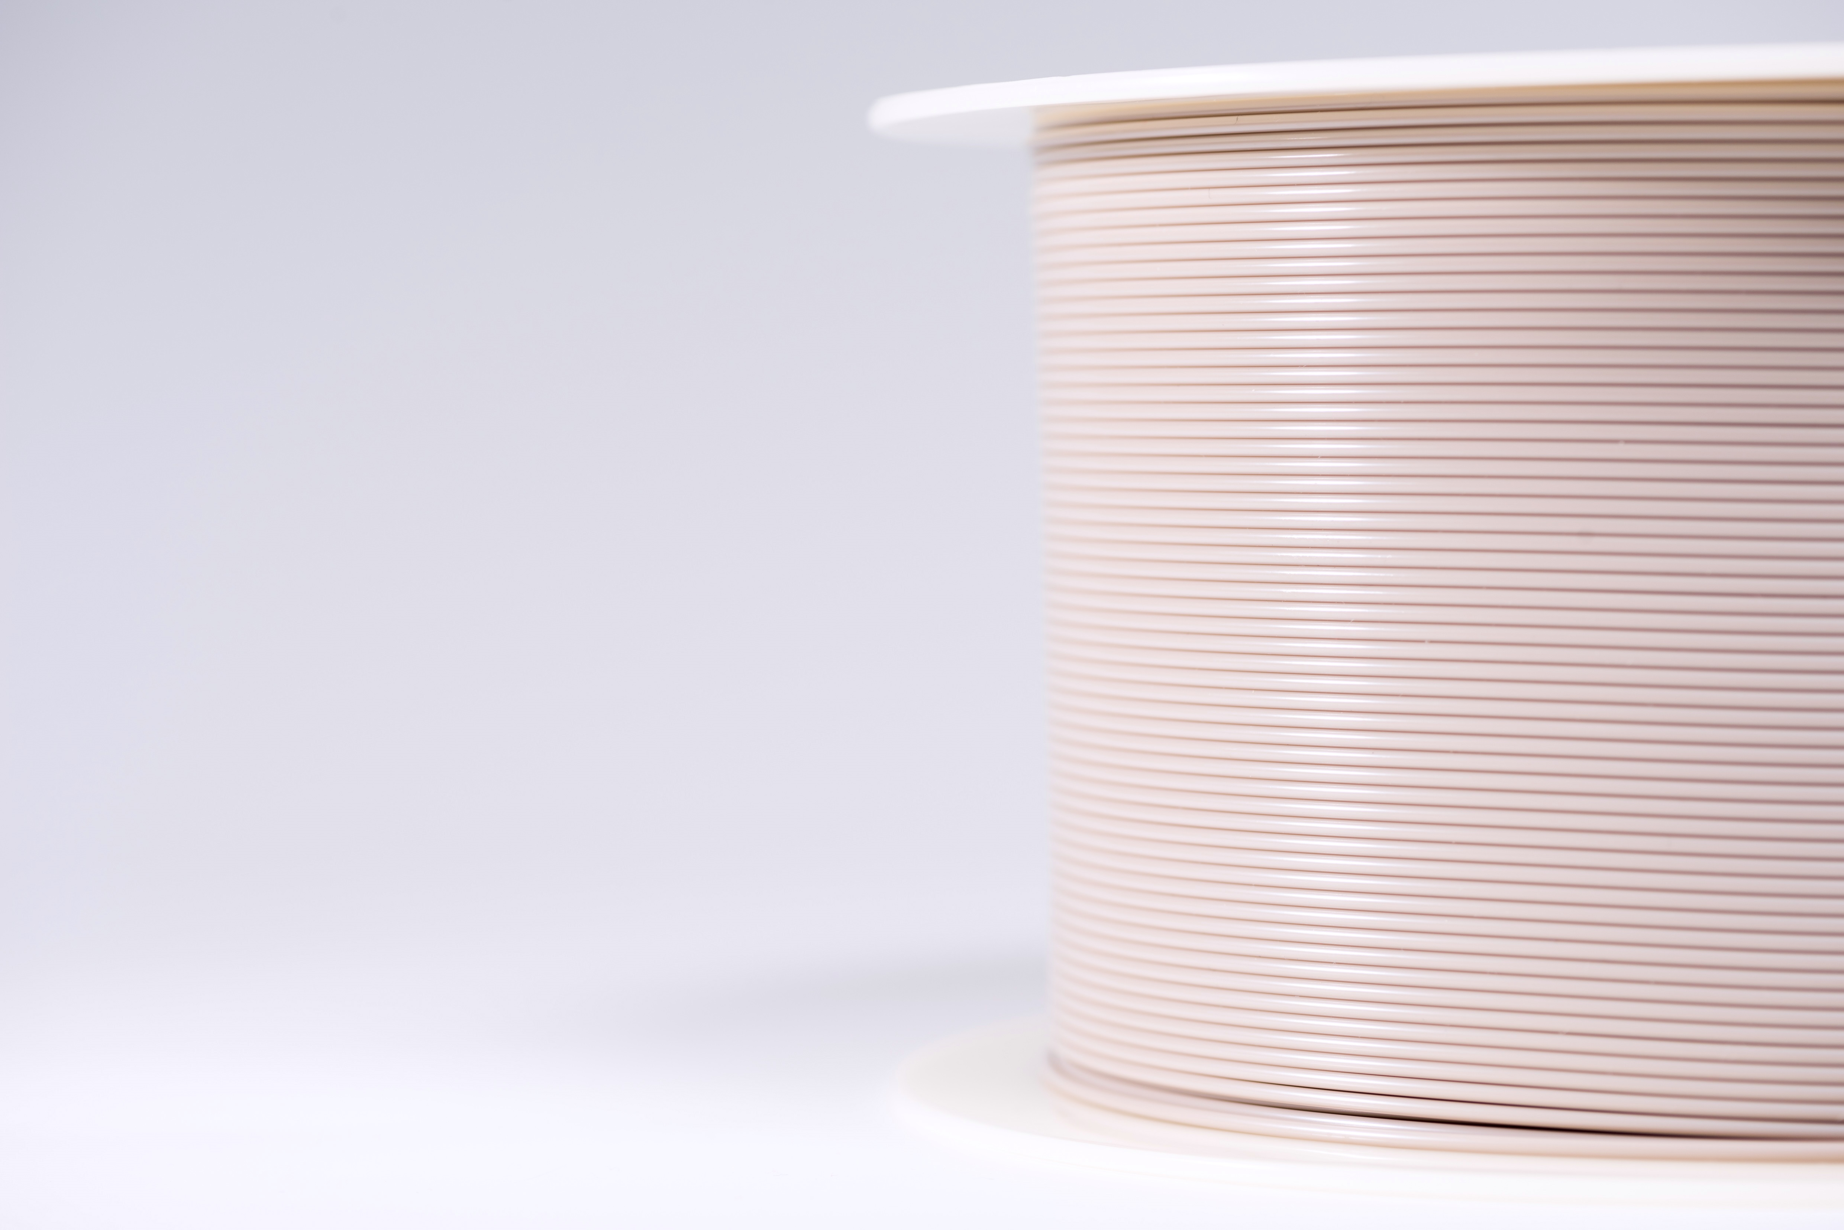
Image caption: Evonik has become the first company in the world to develop a polymer filament based on PEEK (polyether ether ketone) in implant-grade quality for use as a 3D printing material for implants (©Evonik).

Further Information about Evonik’s 3D printing activities you will find on our website www.evonik.com/additive-manufacturing

About Evonik
Evonik is one of the world leaders in specialty chemicals. The focus on more specialty businesses, customer-orientated innovative prowess and a trustful and performance-oriented corporate culture form the heart of Evonik’s corporate strategy. They are the lever for profitable growth and a sustained increase in the value of the company. Evonik benefits specifically from its customer proximity and leading market positions. Evonik is active in over 100 countries around the world with more than 36,000 employees. In fiscal 2017, the enterprise generated sales of €14.4 billion and an operating profit (adjusted EBITDA) of €2.36 billion.

About Resource Efficiency
The Resource Efficiency segment is led by Evonik Resource Efficiency GmbH and produces high performance materials and specialty additives for environmentally friendly as well as energy-efficient systems to the automotive, paints & coatings, adhesives, construction, and many other industries. This segment employed about 10,000 employees, and generated sales of around €5.4 billion in 2017.

Disclaimer
In so far as forecasts or expectations are expressed in this press release or where our statements concern the future, these forecasts, expectations or statements may involve known or unknown risks and uncertainties. Actual results or developments may vary, depending on changes in the operating environment. Neither Evonik Industries AG nor its group companies assume an obligation to update the forecasts, expectations or statements contained in this release.

