VESTAKEEP® PEEK offers the strongest bonding strength to withstand strict operating environmental conditions
October 27, 2014

Thomas Lange
Contact trade press
High Performance Polymers
Phone +49 2365-49-9227
Fax +49 2365-49-809227
thomas.lange2@evonik.com

DELO
Matthias Stollberg
Telefon +49 8193 9900-212
Telefax +49 8193 9900-5212
Matthias.Stollberg@delo.de

Evonik Industries AG
Rellinghauser Straße 1-11
45128 Essen
Germany
Phone +49 201 177-01
Fax +49 201 177-3475
www.evonik.com
www.vestakeep.com

Chairman of the Supervisory Board
Dr. Werner Müller
Executive Board
Dr. Klaus Engel, Chairman
Thomas Wessel
Patrik Wohlhauser
Dr. Uwe Wolf

Registered Office: Essen
Register Court: Essen Local Court
Commercial Registry B 19474
VAT ID no. DE 811160003

The bonding strength of VESTAKEEP® PEEK (polyetheretherketone) L4000G from Evonik Industries has been tested to withstand strict operating environmental conditions. Together with DELO, a manufacturer of industrial adhesives, they have successfully developed an adhesive system to bond with high temperature resistant thermoplastics such as PEEK with other non-compatible materials.

In general, PEEK possesses very low surface energy which leads to poor wettability characteristics. As a result, the surface is extremely resilient to chemical reaction and this makes bonding to PEEK a very difficult process.
However, recent test results demonstrated that VESTAKEEP® PEEK L4000G can be bonded to other materials using an adhesive based on a heat-curing epoxy developed by DELO.

VESTAKEEP® PEEK L400G offers the strongest bonding strength with or without pre-plasma treatment.

DELOMONOPOX AD066, an adhesive designed to bond plastics, developed by DELO can bond VESTAKEEP® PEEK L4000G to other surfaces or components.

To measure the bonding strength between VESTAKEEP®PEEK L4000G and the bonded component, the assembly is subjected to a compressive shear strength test measured after 85 °C storage temperature with 85 % humidity.

When the component surfaces were first pre-treated under atmospheric pressure plasma conditions, the measured compressive shear strength between VESTAKEEP®PEEK L4000G and the test samples showed a measured value of up to 40 MPa.

In a separate test in which the component surfaces were not pre-treated with plasma, the measured compressive shear strength attained a value of around 20 MPa. Although the value is lowered compared to the value measured under plasma treated condition, the benefit here simplifies the production process and its overall manufacturing cost.

In both cases, the bonding strength of the VESTAKEEP®PEEK L4000G test samples - bonded with DELOMONOPOX AD066 - fulfilled the requirements of the industries for plastic bonded systems.
“The combination of VESTAKEEP®PEEK and our epoxy based adhesives is a marriage of high-performance materials,” explains Gudrun Weigel, Head of Engineering at DELO. “The excellent bonding quality is demonstrated by the fact that the test object was deformed first before the bonding failed during compressive shear strength testing. These results have opened up a whole range of new application areas for VESTAKEEP® PEEK.”

VESTAKEEP® PEEK bonding is likely to benefit the aerospace industry in the design of modular components. In the automotive sector and from the mechanical engineering’s design point of view, the VESTAKEEP® PEEK bonding system offers benefits in the sealing design.

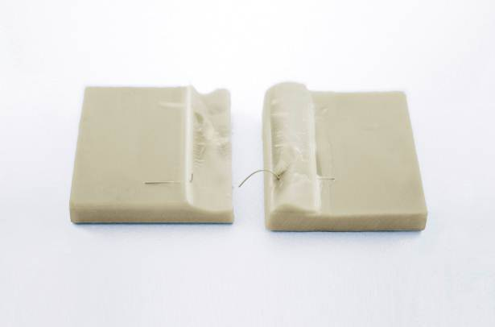

Image Caption
The test object was deformed first before the bonding failed during compressive shear strength testing.
About Evonik
Evonik, the creative industrial group from Germany, is one of the world leaders
in specialty chemicals. Profitable growth and a sustained increase in the value of the company form the heart of Evonik’s corporate strategy. Its activities focus on the key megatrends health, nutrition, resource efficiency and globalization. Evonik benefits specifically from its innovative prowess and integrated technology platforms.

Evonik is active in over 100 countries around the world. In fiscal 2013 more than 33,500 employees generated sales of around €12.7 billion and an operating profit (adjusted EBITDA) of about €2.0 billion.

About DELO
DELO is a leading manufacturer of industrial adhesives with its headquarters in Windach near Munich, Germany, and subsidiaries in the USA, China and Singapore. In the fiscal year 2014, 400 employees generated sales revenues of nearly EUR 60 million. The company supplies customized special adhesives and associated technology for high-tech industries such as automotive, aviation, optoelectronics, and electronics. DELO’s customers include Bosch, Daimler, Infineon, Osram, Siemens and Sony. DELO won the German Industry’s Innovation Award 2014.

Disclaimer
In so far as forecasts or expectations are expressed in this press release or where our statements concern the future, these forecasts, expectations or statements may involve known or unknown risks and uncertainties. Actual results or developments may vary, depending on changes in the operating environment. Neither Evonik Industries AG nor its group companies assume an obligation to update the forecasts, expectations or statements contained in this release.

